

**CONTRACEPTIVE LOGISTICS**

**MANAGEMENT INFORMATION SYSTEM**

Facilitator Manual

September 2014



Table of Contents

Introduction 7

Background 7

Session 1: Introduction and Objectives 9

Session Objectives 9

Session 1.1: Introduction to participants 9

Materials needed 9

Documents to Distribute 10

Presentations required 10

Trainer preparation 10

Activities 10

Activity 1.1: Welcome the participants (Lecture) – Time: 05 minutes 10

Activity 1.2 Self Introduction: Get to know each other (Game) – Time: 15 minutes 11

Activity 1.3 Course Goal and Objectives (lecture) – Time: 20 minutes 12

Activity 1.4: Participants and trainers expectation (Lecture, Game, Q&A) – Time: 20 minutes 13

Session 2: Pakistan’s Pipeline and ordering 17

Learning objectives 17

Content outline 17

Activities 17

Activity 2.1: Interactive presentation. Time: 30 minutes 17

Session 3: Pakistan Contraceptive LMIS Forms 21

Learning objectives 21

Content outline 21

Activities 21

Activity 3.1: Pakistan LMIS forms – Time: 30 minutes 21

Session 4: Basic Logistics Concepts 27

Session Objectives 27

Materials Needed 27

Documents to Distribute 27

Presentations required 27

Trainer preparation 27

Activities 28

Activity 4.1: Introduction to basic logistics concepts – Time: 30 minutes 28

Activity 4.2: Exercise one – Consumption – Time 30 minutes 29

Activity 4.3: Exercise two – Average Monthly Consumption, Time: 30 minute 29

Activity 4.4: Exercise three – Months of Stock, Time: 30 minutes 29

Session 5: cLMIS Introduction And Data Entry 31

Learning objectives 31

Materials needed 31

Activities 31

Activity 5.1: Introduction to cLMIS – Time: 60 minutes 31

Activity 5.2: User names and privileges – Time: 30 minutes 32

Activity 5.3: Orientation to Data entry & Update – Time: 60 minutes 32

Session 6: Inventory Management 35

Session Objectives 35

Materials Needed 35

Presentations required 35

Trainer preparation 35

Activities 35

Activity 6.1: Introduction To Inventory Management – Time: 30 minutes 35

Activity 6.2: Orientation to Inventory Management – Time: 90 minutes 37

Session 7: Requisitions & Gate Pass 49

Session Objectives 49

Materials Needed 49

Presentations required 49

Trainer preparation 49

Activities 49

Activity 7.1: Accessing & Analyzing Requisitions (Lecture + scenarios + discussion) – Time: 60 minutes 49

Activity 7.2: Accessing & Analyzing Gate Pass (Lecture + scenarios + discussion) – Time: 30 minutes 54

Session 8: Dashboards, Reports, Graphs & Maps 57

Session Objectives 57

Materials Needed 57

Presentations required 57

Trainer preparation 57

Activities 57

Activity 8.1: Accessing & Analyzing Dashboards (Lecture + scenarios + discussion) – Time: 60 minutes 57

Activity 8.2: Accessing & Analyzing Reports (Lecture + scenarios + discussion) – Time: 60 minutes 64

Activity 8.3: Accessing & Analyzing Maps (Lecture + scenarios + discussion) – Time: 60 minutes 69

Activity 8.4: Accessing & Analyzing Graphs (Lecture + scenarios + discussion) –Time: 60 minutes 75

Session 9: Troubleshooting and accessing helpdesk 81

Session objective 81

Documents to distribute 81

Activities 81

Activity 1: Troubleshooting 81

Session 10: Group work 83

Session objectives 83

Documents to Distribute 83

Activities 83

Activity 1: Group work 1: Data entry – Time: 2 hours 83

Activity 2: Group work 2: Inventory Management – Time: 2 hours 84

Activity 3: Group work 3: Requisitions & Gate Pass – Time: 1 hour 84

Activity 4: Group work 4: Dashboards – Time: 1 hour 84

Activity 4: Group work 5: Reports – Time: 1 hour 85

Activity 5: Group work 6: Maps – Time: 1 hour 85

Activity 6: Group work 7: Graphs – Time: 1 hour 85

# Introduction

This facilitator manual contains the training sessions for the “Training on Pakistan’s Contraceptive Logistics Management Information System (cLMIS)”. The steps required to design, develop and deliver the “Training on Pakistan’s Contraceptive Logistics Management Information System (cLMIS)” can be found in the “LMIS Training Plan”. The Training Plan outlines the objectives, needs, strategy, and curriculum to be addressed when training users on LMIS.

# Background

The USAID | DELIVER PROJECT (the project) Pakistan has been tasked by the Government of Pakistan with implementing a functioning Logistics Management Information System (LMIS) using a web-based approach. After several months of thorough consultations with all stakeholders from the private and public sectors, the project had adapted and enhanced the web-based application from the Bangladesh model. During the enhancement process, LMIS was contextualized to local stakeholder structure and devolution. The LMIS was launched by Prime Minister of Pakistan on July 2011 as first Logistics Management Information System of Pakistan.

LMIS has the flexibility to integrate other health commodities in addition to contraceptives. DELIVER has plans to integrate other health products to meet the provincial integrated commodity management requirements. In addition to public sector, LMIS application is also able to record contraceptives national sales data of private sector. Currently, the system is able to respond to district level reporting by aggregating facilities level data through paper based reports. The future vision is to enhance the application for facility level reporting on logistics indicators for each district along-with district store commodities status. To strengthen reporting and visibility of private sector contraceptives, district level interface will also be incorporated in LMIS applications which will enables provincial and regional health and population departments to see the contribution of private sector in their geographical areas.

For nationwide implementation of LMIS, the project needed to train the expected users of the system on its uses and functionality. A total of 144 LMIS Operators have been trained from 19 pilot districts to date. The two day training provides skills and knowledge required to independently enter and upload data into web-based LMIS. Web-based LMIS played a significant role in improving stock monitoring in the 19 pilot districts. The real time monitoring helped eliminate stock-outs at district level.

Alongside LMIS implementation, DELIVER has worked closely with federal, provincial and regional governments to advocate for strengthening of the supply chain process through streamlining of supplies and reporting from central to district level. Some of the key policy decisions are considering the stocks at Central Warehouse as national repository and integrated requisitioning through collaboration among stakeholders. In addition, LMIS web-based reporting was declared mandatory for all pilot districts and all other districts as soon as they are automated.

Timely and accurate data entry as well as submission of a monthly report at the district level is critical to the functioning of the LMIS. The data collected from the LMIS can then, subsequently be used at each level of the supply chain to enhance informed decision making to meet service delivery demands. Utilization of the LMIS will depend heavily on the level of understanding of those trained on its various functionalities.

As the project aims to scale-up LMIS to all 140 districts of Pakistan, capacity of all those required to operate LMIS will need to be built. The project aims to identify the right individuals from the government departments and build their capacity in order to ensure sustainability and accuracy of LMIS up to districts and sub-district levels.

# Session 1: Introduction and Objectives

Time: 1.0 hour

Materials required:

* Colored cards 25
* Markers, one for each participant

## Session Objectives

* Know the overall Goal and Objectives of the Course.
* Know the fellow participants.
* Cite personal and group expectations from the course.
* Identify and explain the six Rights and purpose of Logistics Management.
* Individuals are able to explain self-roles and responsibilities in implementing the objectives of Logistics Management Information System at District level.

## Session 1.1: Introduction to participants

Introduce the web-based cLMIS application to the participants and ask about their experience with the release-1 of the application. Some of the participants might be familiar with the application and data entry. Bring the new participants up to speed with the application and its features. Then, introduce the new enhancements and features being implemented in release-2 of the application and give an overview of these features one-by-one.

## Materials needed

* Colored Cards to express expectation
* Name Badge both for participants and trainers
* Multimedia projector
* Charts
* Marker Pens of different colors

## Documents to Distribute

* Handout-1.1: Self-introduction
* Handout-1.2: Training Goal and Objectives.
* Handout-1.3: Six rights of logistics management
* Handout-1.4: Roles and responsibilities of District cLMIS operators
* Handout-1.5: Training schedule

## Presentations required

* Training Goal and Objectives
* Training Schedule
* Session Objectives
* Training norms for participants and trainers during training session

## Trainer preparation

* Prior to starting the session, the trainer(s) must be sure that all materials and equipment needed for the session are ready at hand.
* If the session is planned to be co-facilitated, the co-facilitators should decide, before the session, who will facilitate which part of the session and take preparation accordingly.
* If the session is planned to be co-facilitated, each facilitator should introduce him/herself before start of the session.

## Activities

### Activity 1.1: Welcome the participants (Lecture) – Time: 05 minutes

WELCOME the District cLMIS Operators to the training and CONGRATULATE them for playing a key role in implementing the LMIS. TELL them that the training team aims to impart skills and capacities to each of them so they can successfully implement web-based LMIS at district level. TELL them that the automated reporting of logistics data will improve logistics management drastically and will avert stock-outs of contraceptives and other commodities at district and facility level. MENTION that this is the main focus of this course.

### Activity 1.2 Self Introduction: Get to know each other (Game) – Time: 15 minutes

MENTION that District cLMIS Operators, coming from same District, know each other very well and this is quite natural. But others in this room may not be well known to each other accordingly. Other thing is that the participants and the training team members are also not known to each other. In order to make the course a success, both participants and trainers need to know each other well. TELL them that the training team thinks that prior to starting the course, everybody in this room should know each other well. Explain that this will help us work together better. ASK the participants what do they think? TELL that both the participants and trainers can be known to each other through a simple game.

**Option-1**

Ask participants to write three things about themselves on a piece of paper. Two of these items must be true and third must be a lie. The participants then introduce themselves one by one and tell their three characteristics in any order they wish. The group then has to identify which statement or characteristic is lie by voting.

**Option-2**

EXPLAIN the ground rules of the game.

ASK the participants and the trainers to stand in a circle with pen and paper. TELL that you will ask some questions and they will find the participants who fit into the answers. TELL that they will get 10 minutes time to identify the people and after 10 minutes they will tell the names of their identified people. ASK if the instructions of the game clear to them or not? If not, repeat the instructions.

**Question-1:** Which participants have names starting with A, S, M, N, B, K, J, K. L, R, P, S or H?

**Question-2:** Which participants are working in District Health or Population Welfare Department for five or more years?

**Question-3:** Who has worked as a LMIS trainer before?

**Question-4:** Who has worked as a trainer for three or more years?

**Question-5:** Which participants’ youngest kid is three or less than 3 years?

**Question-6:** Who has travelled the most to attend this training?

**Question-7:** Which participants’ Father / Guardian is still worried for his/her marriage?

**Question-8:** Who likes singing?

**Question-9:** Who is good at playing cricket?

**Question-10:** Who knows how to swim?

Training team member will also participate in this game.

Training team may distribute these questions to the participants in the form of ***Handout-1.1*** (Self Introduction) if they like.

TELL that by participating in this game, I hope that we have known each other in respect of our personal liking, disliking, hobby, family condition, professional life, etc. We believe that we shall pass our time here very nicely if we value and respect all these sort of things.

### Activity 1.3 Course Goal and Objectives (lecture) – Time: 20 minutes

TELL that now we shall discuss Goal and Objectives of the course.

**Course Goal**

ASK one of the participants to read the text: To get participants acquainted with the features of the LMIS application as well as to build institutional capacity towards independent and sustainable data entry, importing and exporting of data and report analysis through cLMIS for decision making.

ASK participants about what do they understand about the statement. TELL participants that each of the LMIS operators has a critical role in enabling their department to independently enter, import and export data. TELL participants that cLMIS has valuable data and the use of which depends on cLMIS operators’ ability to generate reports and graphs. The meaningful analysis can be of great help in preventing stock outs and formulating policy changes responsive to supply chain challenges.

**Course Objectives**

TELL participants that by the end of the training, they will be able to;

1. Enter cLMIS data with almost 100% accuracy
2. Generate required reports, maps and graphs
3. Analyze and interpret reports, maps and graphs
4. Understand cLMIS problem solving approaches and how to contact helpdesk if needed

*Distribute Handout-1.2: Course goal and Objectives to all participants*

### Activity 1.4: Participants and trainers expectation (Lecture, Game, Q&A) – Time: 20 minutes

TELL the participants that they have more practical experience of doing Logistics Management activities in Pakistan than the training team. But the training team has an extensive experience of designing training, developing training curriculum and facilitating training courses. TELL that the course has been designed to implement and to put together the practical experiences of participants and long training experience of trainers.

The training team expects that the course will be enjoyable and fruitful with the spontaneous participation of the participants. Everybody should be careful that the discussion does not become one sided. TELL that this course has been arranged in order to train participants in Logistics Management Information System operations. The course will impart all required skills to successfully enter, upload and analyze logistics data through cLMIS. TELL that the success of web-based system depends highly on their data collection and compilation skills gained in the existing reporting mechanisms. TELL that participants will take part in discussion in the light of their practical experiences which will benefit them in their practical works later on.

TELL that participants might have some expectations out of this course. Similarly, the training team has also some expectations from the participants. TELL that participants’ expectation might be to know the unknown things of cLMIS or to know the things which they do not know well. TELL that the participants will work in small groups, to identify their expectations from this course. They will have five minutes time to list the expectations. DISTRIBUTE charts and marker pen to each group. Prior to starting work, TELL the groups that they will identify their expectations only related to LMIS, and not any administrative or financial aspects, because the training team does not have anything to do in this respect.

At the end of allotted time, ASK each of the groups to tell their expectations. WRITE the key points of their expectations on the chart and paste in a suitable place in the training room so that everybody can see. TELL that the training team will do its best to fulfill all the expectations.

TELL that like participants, the training team has also some expectations. DISPLAY the expectations on Multimedia and ASK the participants if they agree to these. If yes, PASTE these at an easily visible place and draw participants’ attention from time to time, if needed.

CONCLUDE the discussion by saying that both the participants and training team will sincerely try to fulfill the expectations of each other.

**Trainers Expectations**

Course norms (Copy on the FLIPCHART and post in training room)

* Punctuality, both of trainers and trainees
* Respect each other’s opinion and no side talking
* Speak one at a time
* Draw attention of trainer, by raising hand, if there is any question.
* Active participations from all
* Help each other, cooperative learning
* Equal participation and no domination
* Keep mobiles off or on silent mode. Only attend essential calls and that too after permission from trainers
* Friendly behavior with each other and have fun

After the participants have met in small groups and thought about their expectations, review the lists of expectations with the whole group. Record the main ideas coming from the participants. When this is finished, call attention to some of the specific sessions that will be presented during the course, during which the specific expectation will be covered. Also mention any expectations that were mentioned by several participants. Finally, be sure to note (using a red circle or checkmark) any expectations that are **not planned** to be covered during the course.

**How to handle topics not specifically covered**

Comment that while some of the topics mentioned in the expectations may not be covered through specific sessions, these may be discussed throughout the course in other topics (site one or two specific examples as appropriate).

Comment that from the self-introductions, it was obvious that a lot of different expertise exists among the participants as well as the facilitators. Therefore, they should feel free to make use of the expertise of others in the group. For example, if there are topics that will not be covered in depth during the course, it is possible that extensive experience exists among other participants. Comment that in any course such as this, learning can take place between participants as from the facilitator to the participant and participants should take advantage of this opportunity.

Also mention that due to time and other constraints, some topics simply will not be covered but participants are free to discuss among themselves during breaks, lunches, or in the evenings.

# Session 2: Pakistan’s Pipeline and ordering

Time: 30 min

## Learning objectives

By the end of this session participants will be able to:

* Describe Pakistan’s health system, stakeholders and their inter-relationships
* Describe the logistics cycle and flow of information for contraceptives in Pakistan

## Content outline

* Existing reporting structure for various stakeholders
* Job description of all key staff involved

## Activities

### Activity 2.1: Interactive presentation. Time: 30 minutes

TELL students that to understand LMIS properly, they need to have some basic understanding of the system it serves. Studying Pakistan’s system enables us to understand the logistics environment we are working. Tell students they can relate the learning to the role LMIS is playing in strengthening this system.

**Pipeline and Reporting for Pakistan’s Logistics system**

Ask students to identify their own roles in the pipeline. Write the different roles in the supply chain on a flipchart. Ask students to identify how these various supply and reporting roles are linked to each other. The students should be able to share their roles in the supply chain based on their experience. Most of the students are likely to share experiences related to supplies and reporting at the district and sub-district level.

**Contraceptive pipeline**

Tell students that the flowchart describes supply flow for all contraceptive commodities for all stakeholders. The flowchart incorporates recent policy changes regulating the flow of commodities from central to district level. Most of the contraceptives are procured internationally, apart from small local procurements in the past by Lady Health Program for injectable and oral pills. The funding sources include government’s public sector development program (PSDP), USAID and UNFPA. All international procurements are usually shipped through sea and received at Karachi port. Once cleared, the commodities are transported and stored at Central Warehouse (CWH) & Supplies Karachi.

Tell students that the black arrows (pointed downwards) in flowchart indicate the flow of contraceptives while red arrows (pointed upwards) show the flow of orders or requisitions. Tell students that orders are received by Central Warehouse and copied to provincial health and population departments.

**Contraceptive Pipeline – Summary**

Ask students if they have any role in receiving commodities from central warehouse. Tell students that in addition to the flow of commodities, roles and responsibilities are also connected through this flowchart and any break or hurdle in this supply chain will ultimately affect the availability to client.

**How contraceptives are ordered**

Tell students that The Central Warehouse supplies contraceptives based on pull system.

Tell students that in order for pull system to work, the consumption data from all service delivery points has to be recorded. Tell students that all respective service delivery points of the departments of health and population record their consumption and report to districts. The reports by the service delivery points of health department are called First Level Care Facility (FLCF) reports.

Tell students that EDO Health and DPWO offices compile the total demand for their respective departments at district level through the SDP reports. The two departments calculate their demand based on integrated CLR-6. The demand of EDO is then shared with DPWO and DPWO compiles one integrated CLR-6 in order to send to CWH. The EDO also includes the demand of Lady Health Workers Program in addition to requirements from Basic Health Units, Rural Health Centers and Tehsil Headquarter Hospital.

In districts where Peoples Primary Healthcare Initiative (PPHI) manages BHUs, BHUs send its demand to the DPWO which forwards it on to the CWH. Once CWH receives the integrated CLR-6 from each DPWO, it will ship the required quantities to DPWO of that particular district. DPWO will then, receive all required contraceptives for the district and will send required quantities (initially indicated in integrated CLR-6, as discussed above) to each of the FP service provider (DOH & PPHI).

**Pipeline for Health Commodities LHW Program**

Tell students that the flowchart describes the flow of health commodities and LMIS reports in the Lady Health Workers Program. Other programs in the Department of Health (Maternal Neonatal and Child Health, Tuberculosis Program etc.) also follow similar reporting and flow patterns with some variations.

Most of the times, the manufacturer or supplier is contracted to ship the commodities to District stores directly. For other districts, commodities are sent to PPIUs or CWH for storage and onward distribution to districts because some districts have geographical proximity to PPIUs and CWH and are easily supplied through these storage facilities (PPIU, CWH). Once in the district store, the commodities are distributed to LHWs via First Level Care Facilities (FLCF).

LHWs report the consumption of health commodities in the monthly FLCF report which is developed at the FLCF level by the In-charge (physicians mostly) and submitted to District Health Office by the second week of every month.

The District prepares a summary of all reports and sends it to the province. Provinces analyze the logistics data on regular basis to quantify and plan procurements and also sends feedback reports to Districts. The feedback could be informal during the monitoring visits or formally in the form of letters and communications. The districts are supplied by PPIUs based on their orders.

**Job descriptions for Logistics Staff**

Tell students that flow charts gives an overview of various logistics related positions and their reporting lines in public sector. Ask students to categorize various job responsibilities each staff has. They may say:

* Warehousing
* Ordering and receipt of commodities
* Distribution
* Reporting
* or others

List all these categories on flip charts. Ask students to list responsibilities under each category for all positions. Ask students to share their own job responsibilities or their knowledge of functions performed by various levels. Tell students that details of job descriptions are available in **Student Workbook** and they can go through it later.

Tell students to note that they are provided with two additional documents in the form of **handouts** that help explain how commodities and LMIS reports move within the Pakistan Public Health system. These are **Contraceptive Supply and Reporting Flow** and the **Pipeline for Health Commodities for Lady Health Workers Program**. Both have flow charts and explanations included. Encourage students to review these when they can.

# Session 3: Pakistan Contraceptive LMIS Forms

Time: 30 min

## Learning objectives

By the end of this session participants will be able to:

* Describe main features of various Pakistan cLMIS forms
* Describe at least one of the forms from transaction, ordering and reporting category

## Content outline

* An orientation to selected Pakistan LMIS forms

## Activities

### Activity 3.1: Pakistan LMIS forms – Time: 30 minutes

TELL the students that for this next activity they will have the opportunity to look at and analyze some of the forms used in Pakistan’s public health logistics system.

Ask students to recall what they learned from the earlier session on pipeline and reporting flow. The cLMIS is depicted as the engine of supply chain management system. Pakistan has separate paper based LMIS systems for the Department of Health and the Population Welfare Department. The Population Welfare Department (PWD) only deals with contraceptives while Department of Health has other health commodities in addition to contraceptives.

**Population Welfare Department**

Tell students that we will discuss PWD forms in this section.

**PWD LMIS forms**

Tell students that we have chosen three basic forms from the PWD cLMIS. Students can go through other forms available in ‘Ministry of Population Welfare Logistics Manual’ if they are interested. These three basic forms are;

* Stock register: CLR-5
* Requisitioning form: CLR-6
* District Contraceptive Stock Report: CLR-15

**Stock register (CLR-5)**

Ask students to have a look at the stock register and identify what data is collected in this form. Ask students what experience they might have of working with this register. Encourage students to point out deficiencies if any.

**Description – Stock Register**

Tell students that the register is maintained by all warehouses and stores i.e. central and provincial warehouses, district stores, family welfare center stores and RHS-A centers. The Stock Register is used to form stock transactions at a specific level. It forms the information from where the shipments are received and to where they are going along with the names of consignee. The storekeepers can thus refer back to it in case of any discrepancies. The form also contains the signature and remarks of the person receiving or issuing the contraceptives. The Balance column (7) indicates the balance brought forward from the previous register and the result of regular entries thereafter. Tell students that if they wish they may refer to this and other PWD forms in in their **Student Workbook** in the page **titled ‘Population Welfare Department LMIS’** forms. The stock register is shown along with a brief introduction to it.

**Integrated Requisitioning – CLR-6**

Ask students to go through the various rows in integrated CLR-6. Tell students that row A-1 forms consumption at all the facilities for respective stakeholders. A-2 and A-3 give stock at the end of last quarter in district store and service delivery points respectively. A-4 is the total stock (sum of A-2 and A-3). The desired stock for two quarters is usually the twice that of consumption for the recent quarter (A-5)

**Description – Integrated CLR-6**

Tell students that this form is being used by all district level public sector Family Planning Service Providers (DPWO, DOH & LHW, PPHI) for requesting contraceptives from Central Warehouse. A new electronic CLR-6 form has also been introduced in release-2 of cLMIS and it automatically generates the required stock based on the amount of stock used in the previous quarter. This form also indicates the stock status and consumption during the month and indicates the quantity requested for each contraceptive being used.

**District Contraceptive Stock Report (CLR-15)**

Tell students that District Contraceptive Report summarizes consumption data occurring at district level. From the report, one can figure out the quantities which were received by district and the quantities issued to service delivery points. Ask students to focus on the far left column titled “District Store” and tell them that it has the following basic indictors in separate rows (for part 1 which is for district store).

1. Opening balance
2. Received from CWH
3. Issued to field
4. Closing balance
   1. District store
   2. Field
5. Total
6. Expired stock
7. Untraceable stock

Each column is labelled for a commodity, and the information on each commodity is captured in its specified column.

**Description-District Contraceptive Stock Report (CLR-15) Part-II**

Tell students that the report has two parts. Part-I is related to the stock status at the District Store and Part-II indicates the stock and sales status at various categories of the field operational units. The commodities issued from district store should be the same as received by field level. The commodities issued from field levels (indicated as sold in the form) are used as a proxy for consumption where ‘dispense to user’ data is not available.

This section is completed by the field and it has following indicators:

1. Opening balance
2. Received form district store
3. Sold (as commodities are sold at facilities at nominal prices)
4. Closing balance

Each column is labelled at the top with a commodity and information on that commodity is formed in it.

**Department of Health**

Tell students that in this section they will discuss forms used by Department of Health (Lady Health Workers Program).

**Bin card**

Ask students if they have used Bin cards in their routine work. Ask anyone of those who has experience to describe what it is and how it is filled. Tell students that one bin card is used for each commodity. The left most Date column is used to form date of any transaction.

The column labelled ‘Quantity’ will indicate quantities received or issued (noted in respective sub-columns). The balance is calculated by addition / subtraction from the opening balance.

**Receipt**

The commodities received from provincial or central warehouse depending upon the warehouse level.

**Issued**

Issued to service delivery points or the district stores depending upon the warehouse level.

Have students open their **Workbook** to **LHW LMIS Forms Bin Card** and review the procedures with them for completing the Bin Card.

**Description – Bin card**

Tell students that bin card indicates the balance of an item available in stock; it must be used for all levels of storage facilities. However, these are only as good as how often they are updated. Ask students to relate the example from the description.

**First level care facility (FLCF) report**

Tell students that the FLCF report is prepared at the service delivery points (BHU, RHC) and sent to Districts within first week of the month. This FLCF report contains quantities received at the facility from DPIU. The report also provides quantities of commodities issued to LHWs or dispensed to clients directly from the facility. Quantities received from DPIU.

* Quantities distributed to LHWs
* **Present / current stock:** This is calculated by adding any quantities received during the month to the previous months closing balance and deducting the amount issued to LHWs from the total.
* **Days out of stock:** The indicator reports the number of days a facility was stocked out of a particular commodity

Explain that these were a few of the cLMIS forms used by the PWD and the LHW systems. Tell students that these systems, and the cLMIS forms they use, are evolving and likely to change as new efficiencies are developed.

Here are examples of useful discussion questions that can be adapted to each group of students according to their needs and how well they have mastered the forms so far. The answers are in brackets?

1. Which form would be the easiest for a new person to understand and use? [probably the inventory control card, such as a stock card or bin card]
2. Which form is the most challenging mathematically and why? [Transaction forms, since the other two types have just addition and subtraction.]
3. Which form(s) would never be computerized? [Probably the stock card and bid card.]
4. Which form(s) have data on them that is aggregated? [All of them do, in so far as the data from the stock cards and consumption forms is put on the transaction form that is sent up to be eventually be aggregated.]
5. If you were visiting a store room, what form would you want to study closely? [Stock card or bin card. There are no consumption forms or transaction forms in a store room.]
6. Which column on any of the forms is likely to have the most mathematical errors? [Some discussion here, but it is probably the Quantity to Order column on the transaction form, since it requires the most calculations.]

# Session 4: Basic Logistics Concepts

Time: 2.0 hours

## Session Objectives

* To make participants understand consumption, average monthly consumption and months of stock
* To enable to calculate the aforementioned indicators for their own district
* To make supply decisions based on these indicators

## Materials Needed

* Multimedia Projector
* Charts
* Calculators

## Documents to Distribute

* Handout (description of basic concepts)
* Exercise 1, 2 & 3
* Answer key for exercises

## Presentations required

* Basic logistic concepts

## Trainer preparation

* Prior to starting the session, the trainer(s) must be sure that all materials and equipment needed for the session are ready at hand.
* If the session is planned to be co-facilitated, the co-facilitators should decide before the session that who will facilitate which part of the session and take preparation accordingly.

## Activities

### Activity 4.1: Introduction to basic logistics concepts – Time: 30 minutes

APPRECIATE participants on successfully updating the data. TELL participants that once the data entry is done, it is visible worldwide and can be used for logistics decision and policy formulation. Stress the importance of utilizing data from district to national level. TELL participants that their role is not just limited to data entry but they should be proactive in using this data for district based logistics management. Each cLMIS operator MUST understand his/her role in analyzing and interpreting cLMIS data. TELL participants that in order to understand reports, they must grasp some basic logistics concepts. TELL participants that they may already be aware of some concepts from Release-1 and the exercises contained in this session will refine them further. Then, PRESENT and elaborate basic logistics concepts.

ASK participants what they understand by consumption of contraceptive. They may possibly reply that it is dispensing of contraceptives at the facility level or issuance of contraceptives to facilities by district store. TELL participants that ideally the consumption is computed by issuance / dispensing of contraceptives at the facility level to the clients. However, issuance of contraceptives to facilities by district store can be considered as proxy for consumption in case facility level issuance data is not available. In cLMIS, we are using the district level issuance data as consumption.

TELL participants that it is important to compute the average monthly consumption for forecasting and other policy decisions as consumption may vary from month to month due to various reasons. ASK participants on how they calculate their flour or other home requirements and how frequently they replenish those items. They may respond that every month they buy a month’s consumption based on what has been consumed previous month. TELL participants that contraceptive requirements can also be estimated keeping this principle in mind, however the estimation has to be more accurate. For a relatively accurate requirement of next month or so, Average Monthly Consumption is computed. TELL participants that AMC is computed by taking the average of previous three non-zero months, i.e.

**Average Monthly Consumption (AMC) = last three non-zero months / 3**

Non-zero months are those in which the reported consumption was not zero.

ASK participants that how they will estimate that how much time their current stock will last. They may respond that it will depend on future consumption. TELL participants that in order to estimate how much time their current stock will last, they will calculate ‘months of stock’ (MOS). MOS will inform us the number of months’ time before all stock is consumed. TELL participants that MOS is calculated by dividing the current Stock on Hand (SOH) by AMC.

**Months of Stock = SOH / AMC**

### Activity 4.2: Exercise one – Consumption – Time 30 minutes

Give exercise one to all participants. ASK them to perform this exercise individually. TELL participants that they can do their calculations on calculator or excel sheet. GO around the hall to check if participants are having any difficulty in doing the exercise.

ASK participants to share their results. Compare the results with answer key and redo the calculation to make everyone understand how consumption is computed.

### Activity 4.3: Exercise two – Average Monthly Consumption, Time: 30 minute

Give exercise two to all participants. ASK them to perform this exercise individually. TELL participants that they can do their calculations on calculator or excel sheet. GO around the hall to check if participants are having any difficulty in doing the exercise.

ASK participants to share their results. Compare the results with answer key and redo the calculation to make everyone understand how average monthly consumption is computed.

### Activity 4.4: Exercise three – Months of Stock, Time: 30 minutes

Give exercise three to all participants. ASK them to perform this exercise individually. TELL participants that they can do their calculations on calculator or excel sheet. GO around the hall to check if participants are having any difficulty in doing the exercise.

ASK participants to share their results. Compare the results with answer key and redo the calculation to make everyone understand how average monthly consumption is computed.

# Session 5: cLMIS Introduction And Data Entry

Time: 2.5 hour

## Learning objectives

At the end of the session, participants will be able to:

* Use cLMIS web-based application
* Identify various functions contained in cLMIS application
* Browse the application and obtain desired outputs
* Describe stakeholder specific login and determine user privileges
* Describe the process of data entry

## Materials needed

* Laptops for each participant (with external mouse, Microsoft Office, Internet explorer, Mozilla Firefox or Google Chrome, Wi-Fi)
* Calculators for each participant
* Date entry exercise
* Multimedia projector
* Local module setup CD
* Central module server simulator
* Network switch (to establish local area network)

## Activities

### Activity 5.1: Introduction to cLMIS – Time: 60 minutes

Open cLMIS – Feature and Enhancements presentation and display it using the projector.

**Introduction to LMIS and data entry**

TELL participants that the basic role of cLMIS operators is to enter data into the application. This session will explain all steps required to carry out successful data entry.

Tell participants that in this session we will learn what cLMIS is and how it can be accessed using Windows XP, Windows 7 or 8.

Tell participants about Team-viewer - what is team viewer and how it can be used for remote/telephonic support.

Tell them that “User ID” and “Password” is required to access the application.

TELL participants to type in <http://lmis.gov.pk/> into their web-browser. TELL participants that this is web-based module they are accessing. Ask participants if they are able to see the web page. TELL participants that the module can only be accessible if you are connected with the internet. Ask participants to check if they can successfully access the internet and the LMIS application. TELL participants to log into the application using the assigned credentials.

### Activity 5.2: User names and privileges – Time: 30 minutes

Tell participant the convention used for usernames in LMIS. Tell participants that PWD user name prefix is “DPWO_” and post fix is district name. Likewise DoH & LHW usernames prefix are “EDO_” & “DPIU_” respectively. Now tell participants to open home pages of cLMIS module and login with respective districts and stakeholder. Help participants to login.

Tell participants to login with same username in it and show users that user can view reports, monthly reports, inventory management, maps, graphs, LMIS explorer and data entry options.

### Activity 5.3: Orientation to Data entry & Update – Time: 60 minutes

Tell participants that data entry for logistics reporting in one time activity in a month.

Tell users to open cLMIS homepage using the provided credentials. Also tell them to select Data Entry option from the main menu to show the report. Each district will show a list of stores/facilities as well as field offices in the said district. The report will only show for the current reporting month.

TELL participants that user has to report on the following indicators;

* Opening balance
* Received
* Issued
* Adjustments (+ / -), and
* Closing balance

TELL participants that district store data is available stocks and issues from the district store and facility level data is aggregate of stocks and issues from all facilities that report to respective district.

Explain participants about read-only (grey box) and editable (white boxes) fields, where user can enter data and where data can be calculated automatically based on information added in white boxes.

Tell participants to look into training folders for the data entry exercises. TELL participants that they are provided with dummy data from three service delivery points. They will need to aggregate the SDP data on a blank sheet labeled as ‘Aggregated Filed Monthly Contraceptive Report’. TELL participants that they are also provided with dummy district store data labeled as ‘District Monthly Contraceptive Report’.

Tell participants to use calculators or excel spreadsheets for aggregate facility level data. Pay attention to all participants while they are doing aggregation exercise and help them where they feel difficulty to perform calculations. When participants are done with calculations, then display results of exercises results on projector screen to verify the results.

After calculation exercises advise participants to enter data for district store and aggregated field data in the application and save it. Repeat this exercise to enter data for another month.

# Session 6: Inventory Management

Time: 2.0 hours

## Session Objectives

Participants will be able to:

* Perform inventory management activities such as receive and issue stock
* Analyze stock placement, location and stock pick
* Analyze and add adjustments in stock

## Materials Needed

* Laptops
* Board and board markers

## Presentations required

* Inventory Management

## Trainer preparation

* Prior to starting the session, the trainer(s) must be sure that all materials and equipment needed for the session are ready at hand
* If the session is planned to be co-facilitated, the co-facilitators should decide before the session, who will facilitate which part of the session and take preparation accordingly

## Activities

### Activity 6.1: Introduction To Inventory Management – Time: 30 minutes

CONGRATULATE participants on successfully understanding the basics of data entry in the last session. TELL participants that they will now be able to understand and practice inventory Management. TELL participants that they need to clearly understand how to issue and receive stock as well as how to manage and pick stock.

ASK participants to share their understanding of how stock is received from supplier or warehouse and which process is followed to successfully issue stock from the district store to basic health facilities.

TELL participants that we are now going to talk in detail about inventory management.

Tell participants about the basic concepts of Inventory Management. Tell them that this module supervises the flow of goods from manufacturers to warehouses and from these facilities to the point of sale. One of the key functions of inventory management is to keep a detailed record of each new or returned product as it enters or leaves a warehouse or the point of sale.

Demonstrate how to ACCESS Inventory Management by opening the LMIS first <http://www.lmis.gov.pk/>

Tell participants to open the Inventory Management module from the main menu. A list of options will be shown.

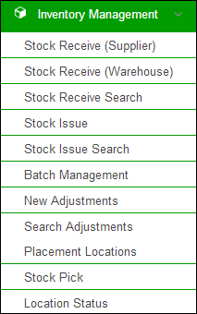

* **Stock Receive from Supplier:** Users can receive stock directly from supplier.
* **Stock Receive from Warehouse:** Users can also receive stock from other warehouses.
* **Stock Receive Search:** Users can search the received stock from other warehouses or suppliers.
* **Stock Issue to Warehouses:** The stock is issued to warehouses/stores on demand.
* **Stock Issue Search:** Users can search the issued stock to other warehouses.
* **Batch Management:** When stock is received, the user marks the batches with latest expiry date as ‘Running’, so that this stock can be issued first.
* **Stock Adjustments:** If stock is lost or recovered, user can add adjustments in cLMIS.
* **Search Adjustments:** User can search the added adjustments for a selected duration.
* **Manage Locations:** User can manage the location of stock within the store / warehouse.
* **Location Status:** User can check the stock available at a particular location in the store and transfer it to another location.
* **Stock Pick:** User can select Issue No. to pick a particular product from the voucher list.

Explain each option one by one and tell participants that the module is different for district and central users as they have different levels of user privileges.

ASK all participants to browse to Inventory Management and GO around the hall to confirm all have been successful.

### Activity 6.2: Orientation to Inventory Management – Time: 90 minutes

BROWSE to Stock Receive (Supplier) by first placing the cursor onto Inventory Management and then in the reports sub-menu selecting the ‘Stock Receive (Supplier)’.

DESCRIBE the Stock Receive (Supplier) process. Tell participants that they can receive stock directly from the supplier by using this option. User can add information such as Funding Source, Product, Manufacturer and batch information i.e. Batch No, Expiry Date and Quantity of the required product.

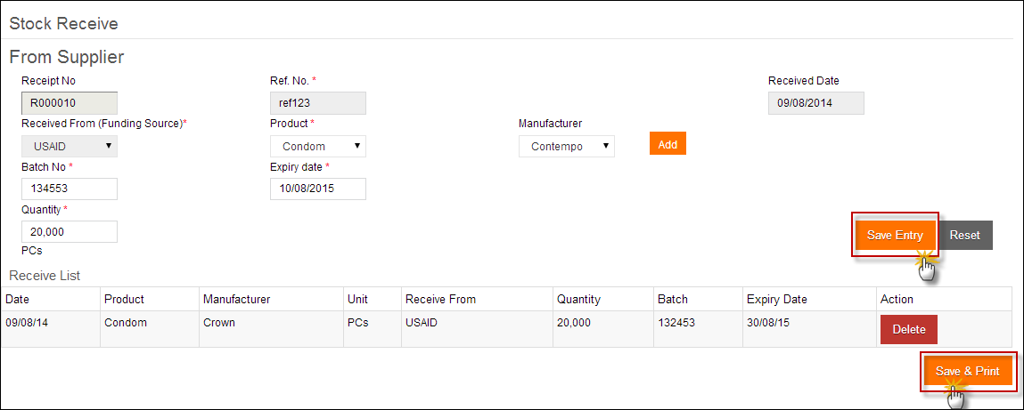

TELL participants that once user saves the receive list, The Receive order is saved and a Stock Receive Voucher is created.

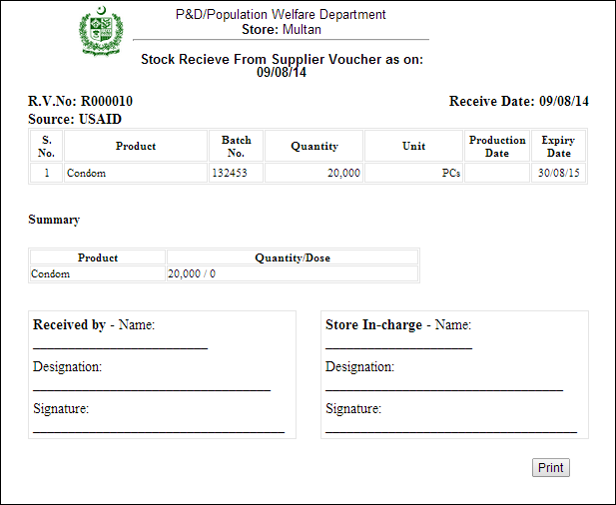

Give scenario-1 to participants and ASK them to create an entry to receive stock from supplier. Tell participants to save the added entry by clicking “Save & Print”. GO around the hall to ensure that everyone has completed the exercise.

DESCRIBE the Stock Receive (Warehouse) process. Tell participants that they can receive the stock being issued by the central warehouse. Storekeepers will be able to receive products against the issue voucher number provided by the central warehouse user.

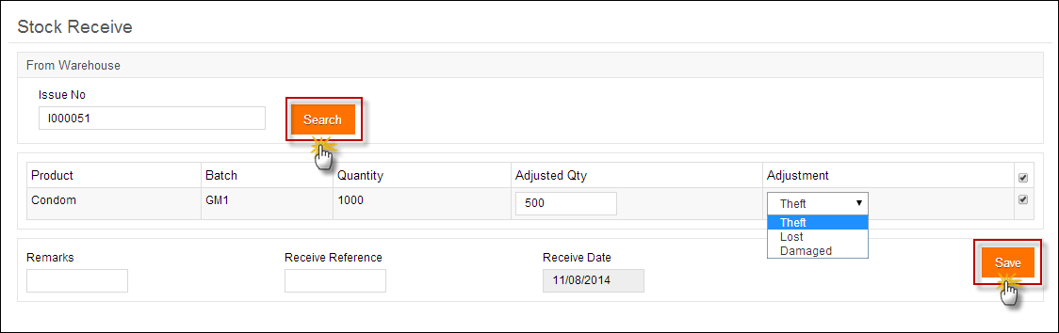

Give scenario-2 to participants and ASK them to search an entry using the Issue No. Tell participants to add adjustment in the product quantity and save the entry by clicking “Save”. GO around the hall to ensure that everyone has completed the exercise.

DESCRIBE the Stock Receive (Search) process. Tell participants that they can search received stock by Receive No, Receive Ref or Batch No. Users can also select Warehouse Supplier and Product to search a particular stock.

The required entries will be displayed in the Receive Search list.

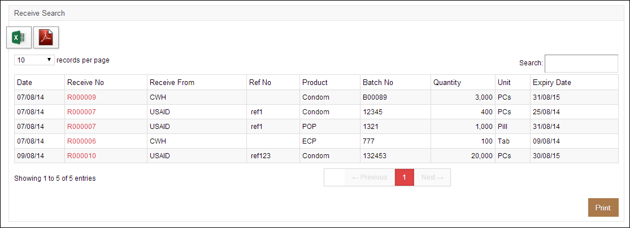

Give scenario-3 to participants and ASK them to search received stock by Receive No, Receive Ref or Batch No. GO around the hall to ensure that everyone has completed the exercise.

DESCRIBE how to manage the stock placement locations. Tell participants that they can manage placement locations for the stock within the warehouse by adding location Area, Row, Rack, Rack Type, Pallet as well as Level.

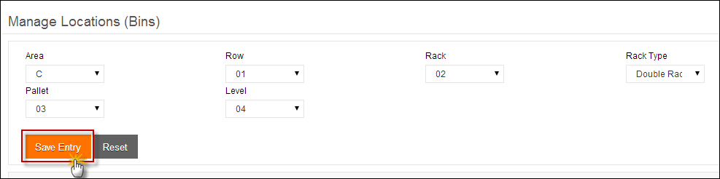

A list will be displayed. Tell participants that they can also search for a stock location from the list.

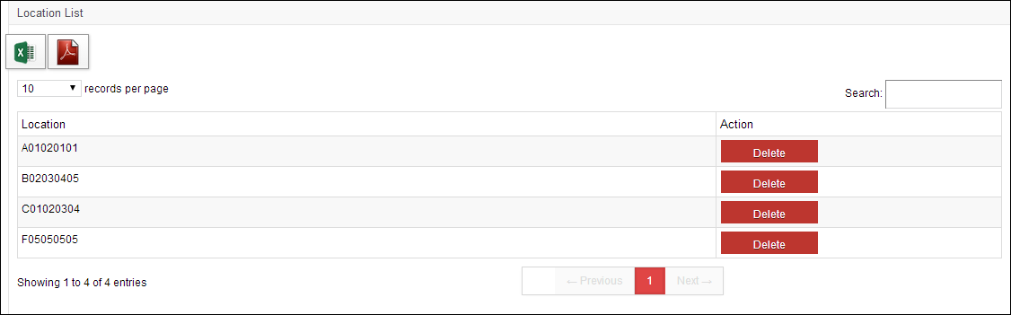

**Search locations for stock.**

Give scenario-4 to participants and ASK them to add stock placement locations. GO around the hall to ensure that everyone has completed the exercise.

DESCRIBE how users can select Area and Level to show a particular location for allocating the stock within the store / facility.

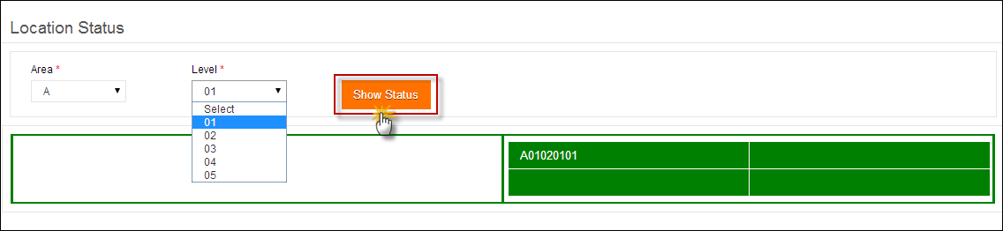

**Click the displayed location.**

Tell participants that when user clicks the placement location, the details of the product present at that location appears.

Also tell participants that they can transfer the stock available at this location by adding the quantity of boxes under Transfer. (The quantity of boxes to transfer should be less than or equal to the available number of boxes.

Tell participants that they can also add more stock to this particular location.

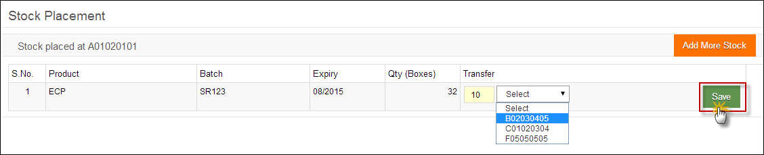

A complete list of received stock will be displayed. Tell participants that they can select the unallocated boxes to add stock at a particular location.

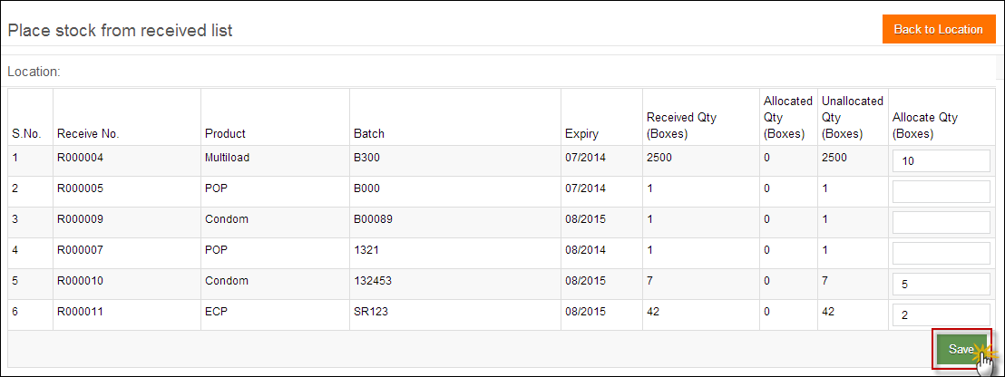

Give scenario-5 to participants and ASK them to search for a location, transfer and add more stock to the location. GO around the hall to ensure that everyone has completed the exercise.

DESCRIBE how users can perform batch management for the received stock. Tell participants that once the stock is received in warehouse, each package is identified by its Batch Number and Expiry Date. Each batch is sorted by its expiry date by the rule of “First Expiry First Out”. When batches of stock are added to cLMIS, the account user usually assigns the batches with latest expiry date as ‘Running’ and the running batches are issued first. Each batch has a status i.e. Running, Stacked and Finished. Tell participants that they will be able to change the status from Running to Stacked as desired.

Also, tell participants that stock can be issued only if their batch status is set to Running by the system. One or more batches can be set to running depending on the quantity and expiry date of the product.

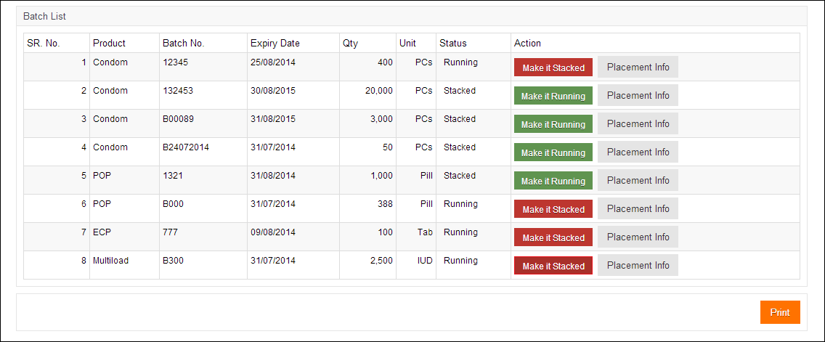

Give scenario-6 to participants and ASK them to search for batches of one product and make those running. GO around the hall to ensure that everyone has completed the exercise.

DESCRIBE that central users can issue stock based on the districts requisition (CLR-6) while district users can issue stock to health facilities on the bases of sub-district product consumption. Provincial and district storekeepers can also issue the stock back to the respective upper level store if required. The newly added entry will be displayed in the Issue list.

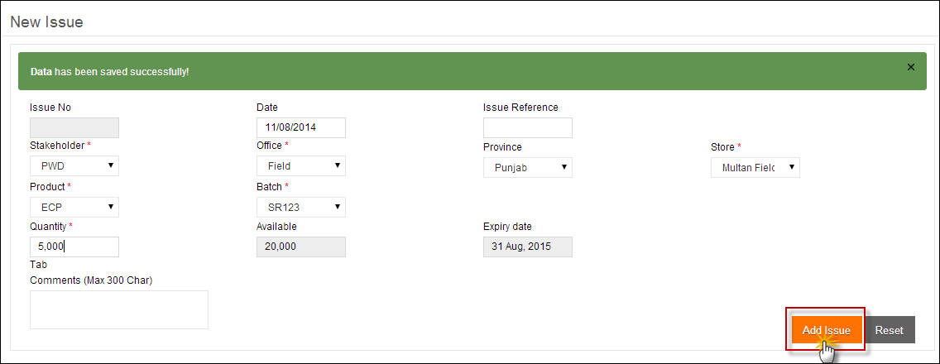

Give scenario-7 to participants and ASK them to issue stock to a particular store. GO around the hall to ensure that everyone has completed the exercise.

DESCRIBE the Stock Issue (Search) process. Tell participants that they can search issued stock by Issue No, Issue Ref or Batch No. Users can also select Warehouse Supplier and Product to search a particular stock.

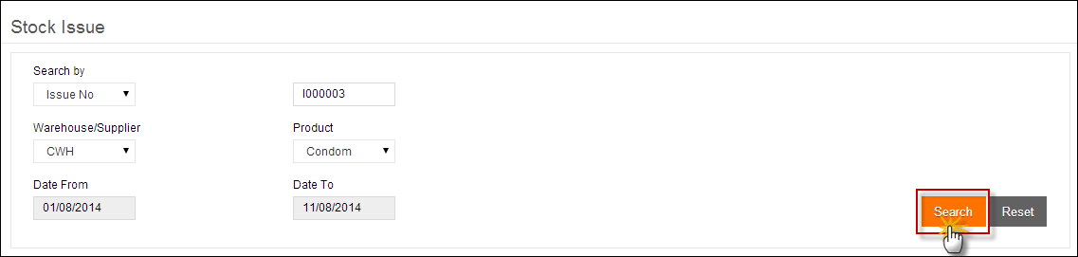

The specified issued stock will appear in the Issue Search list.

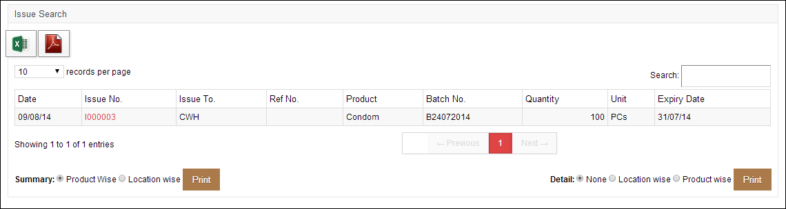

Give scenario-8 to participants and ASK them to search issued stock by Issue No, Issue Ref or Batch No. GO around the hall to ensure that everyone has completed the exercise.

DESCRIBE the stock pick process and tell participants that they can pick the issued stock from a location in the warehouse using Issue No. Tell participants to select the Issue No. to pick a stock of any particular product from the Issue Voucher List and click Pick.

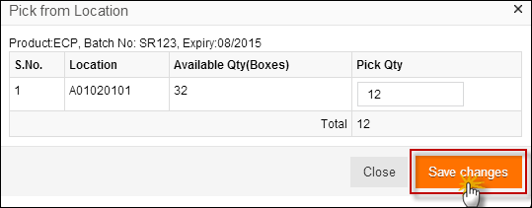

Give scenario-9 to participants and ASK them to pick the issued stock using the Issue No. GO around the hall to ensure that everyone has completed the exercise.

DESCRIBE the add adjustment process and tell participants that they can update the number of items in stock manually in case of lost and damaged items or if they have received less inventory than expected.

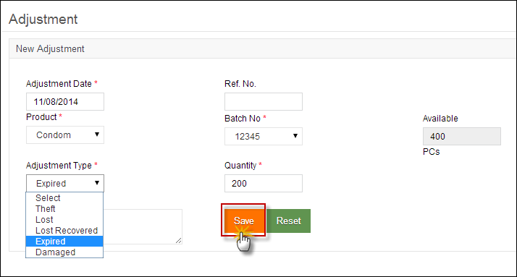

**Specify Adjustment Details.**

Give scenario-10 to participants and ASK them to add adjustments in the stock. GO around the hall to ensure that everyone has completed the exercise.

DESCRIBE the search adjustment process and tell participants that they can also search adjustments added in the stock by adjustment type and product.

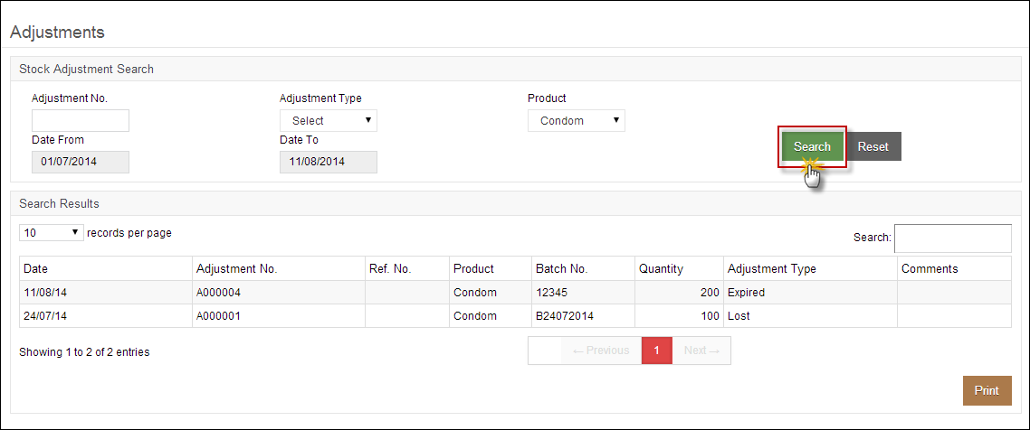

Give scenario-11 to participants and ASK them to search adjustments in the stock. GO around the hall to ensure that everyone has completed the exercise.

# Session 7: Requisitions & Gate Pass

Time: 1.30 hours

## Session Objectives

Participants will be able to

* Add, analyze and view requisition requests (CLR-6)
* Add, analyze and view gate pass

## Materials Needed

* Laptops
* Board and board markers

## Presentations required

* Reports
* Graphs
* Maps

## Trainer preparation

* Prior to starting the session, the trainer(s) must be sure that all materials and equipment needed for the session are ready at hand.
* If the session is planned to be co-facilitated, the co-facilitators should decide before the session, who will facilitate which part of the session and take preparation accordingly.

## Activities

### Activity 7.1: Accessing & Analyzing Requisitions (Lecture + scenarios + discussion) – Time: 60 minutes

CONGRATULATE participants on successfully understanding the basics of inventory management in the last session. TELL participants that they will now be able to understand and interpret requisition requests easily. TELL participants that they need to clearly understand how to place a CLR-6 request electronically as well as view it within the application.

TELL participants that we are now going to talk in detail about requisitions. Ask participants about their understanding of requisition request and how these request are placed.

Tell participants that stock Requisition (CLR-6) form is being used by EDO (H) for commodities request from CW&S. EDO (H) staff prepares this requisition form on quarterly basis in consultation with storekeeper of DPWO. This form indicates the stock status and consumption during the quarter and indicates the quantity request for each contraceptive being used in respective districts.

EXPLAIN the process of placing requisition requests for approval. Tell participants that previously, users were required to fill out Requisition (CLR-6) based on the previous consumption of that district and submit to the Central Warehouse. However in Release-2 of cLMIS, Requisition (CLR-6) is auto generated using previous consumption trends for the required quantity of products for the next quarter.

SHOW participants that new requisition (CLR-6) auto-fills the fields by using previous consumption data of a district in a selected quarter. Tell users that they can create requisition and electronically submit it to the central warehouse. These requisitions will be reviewed by the management of central warehouse and stock will be issued as per stock availability and approval.

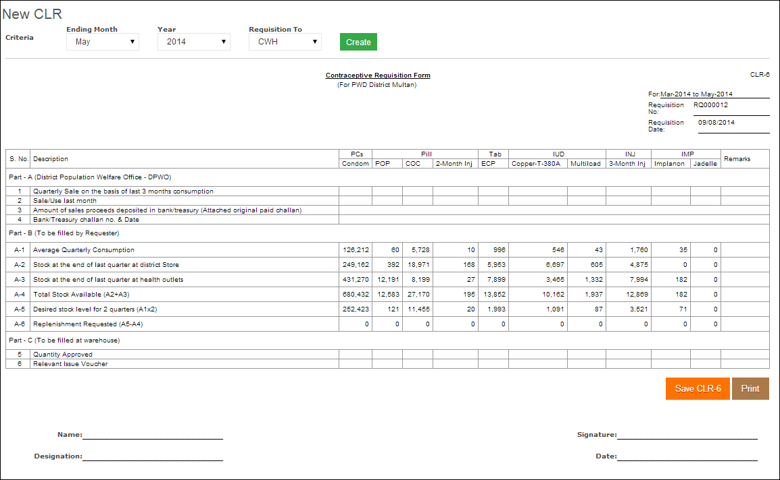

SHOW participants that they can view a comprehensive list of requisition requests placed to other warehouses or stores.

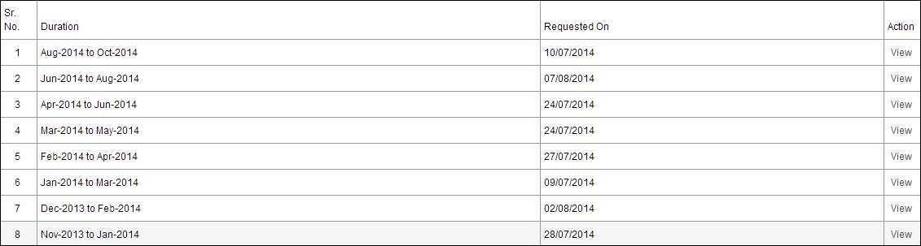

Tell participants that they can also see details of each requisition from this list.

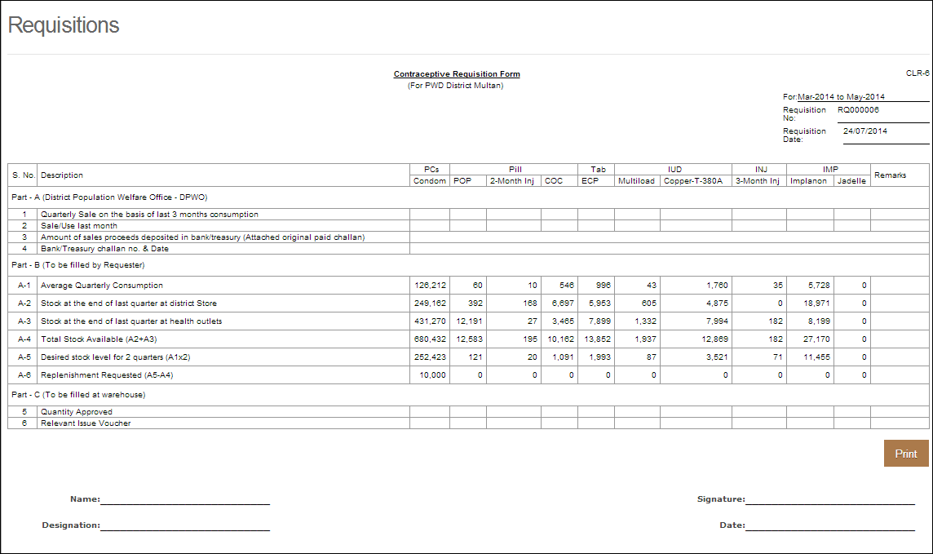

TELL participants that central warehouses can manage requisition requests placed by the district stores or facilities. Central users can approve these requisition requests placed by the district users.

cLMIS provides option to view detail Requisition (CLR-6), stock issue voucher against any requisition and approve.

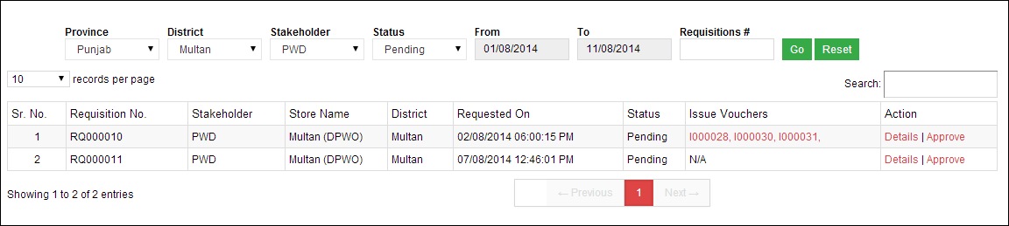

Tell participants that they can use the Issue Voucher number to see the details and print the voucher.

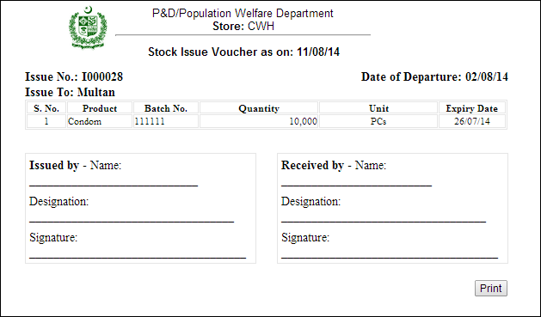

Tell participants that central users can view the details of the requisition request placed by the district user.

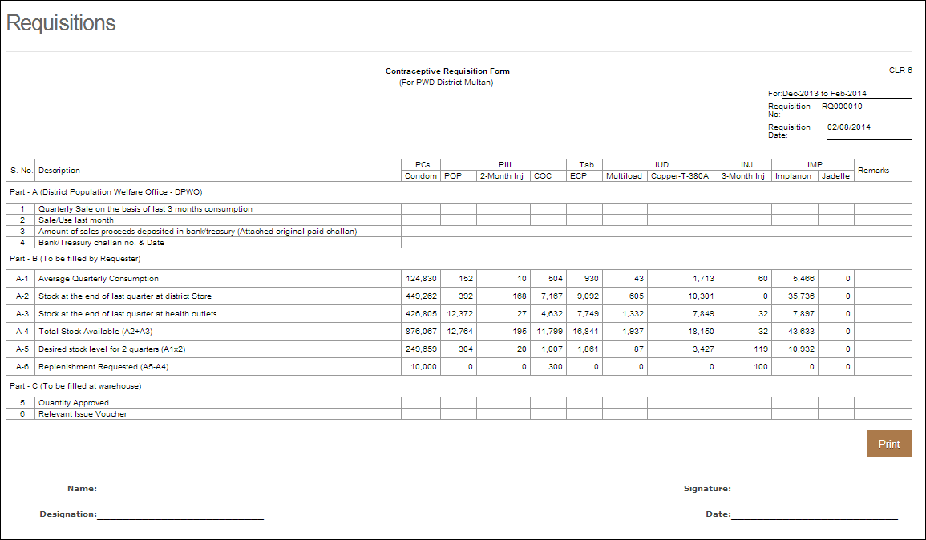

Also tell participants that they can approve or decline the requisition request placed by the district user.

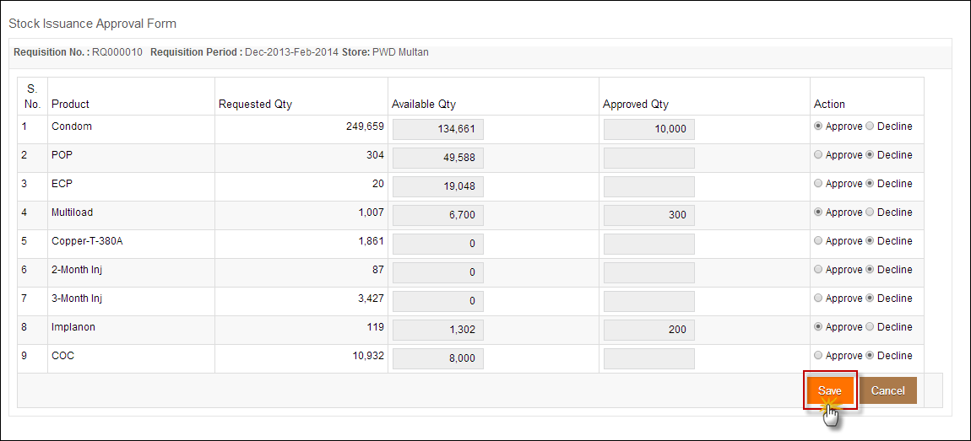

### Activity 7.2: Accessing & Analyzing Gate Pass (Lecture + scenarios + discussion) – Time: 30 minutes

CONGRATULATE participants on successfully understanding the basics of requisition requests in the last session. TELL participants that they will now be able to understand and interpret gate pass easily. TELL participants that they need to clearly understand how to issue a gate pass electronically as well as view it within the application.

TELL participants that we are now going to talk in detail about how to issue and view gate pass. Ask participants about their understanding of gate pass and why it is important to create gate pass. EXPLAIN the process of gate pass issue. Tell participants that once stock has been picked to be transferred to another location, a new gate pass needs to be created.

TELL participants that a new gate pass can be created by providing the vehicle and its type to transfer the stock to another location.

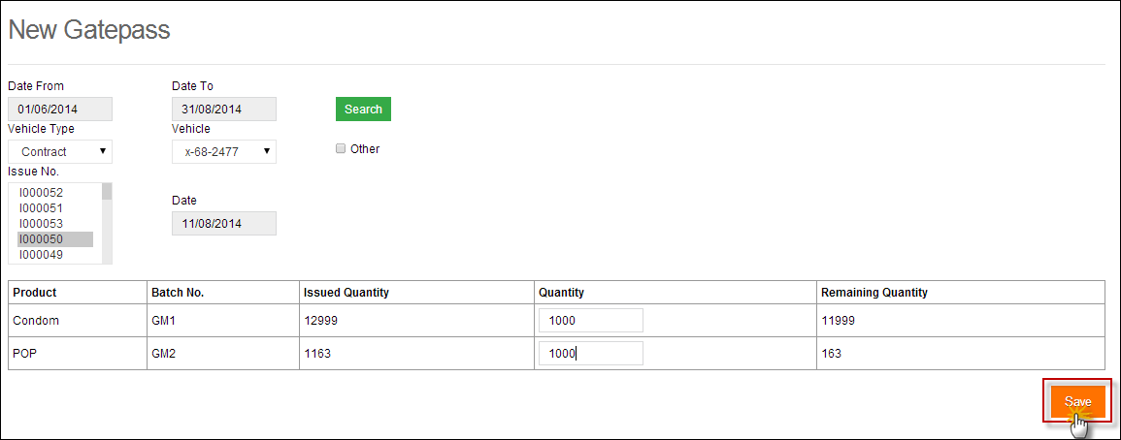

**Select the filters to create a new gate pass.**

**Search a gate pass from the displayed list**

TELL participants that they can view a list of gate passes issued within a selected time duration.

**Click Go**

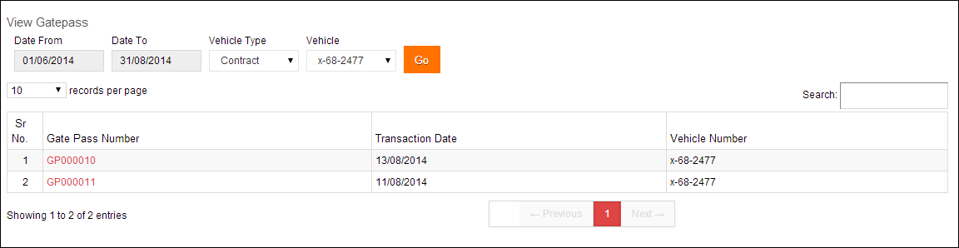

# Session 8: Dashboards, Reports, Graphs & Maps

Time: 4:00 hours

## Session Objectives

Participants will be able to

* Access various dashboards reports, graphs and maps contained in the cLMIS application
* Analyze and interpret data in reports, graphs and maps

## Materials Needed

* Laptops
* Board and board markers

## Presentations required

* Reports
* Graphs
* Maps

## Trainer preparation

* Prior to starting the session, the trainer(s) must be sure that all materials and equipment needed for the session are ready at hand.
* If the session is planned to be co-facilitated, the co-facilitators should decide before the session, who will facilitate which part of the session and take preparation accordingly.

## Activities

### Activity 8.1: Accessing & Analyzing Dashboards (Lecture + scenarios + discussion) – Time: 60 minutes

CONGRATULATE participants on successfully understanding the basics of requisition and gate passes in the last session. TELL participants that they will now be able to understand and interpret dashboards, reports, maps and graphs easily. TELL participants that they need to clearly understand how to interpret Dashboards in cLMIS.

ASK participants to share their understanding of how the data is represented on the dashboard. They may respond that it is collected and computed in central server and represented in the form of maps, reports and graphs.

SHOW them the schematic diagram depicting data flow to and from the central server and TELL them how the web-based cLMIS application connects the user and central server.

TELL participants that we are now going to talk in detail about cLMIS dashboards. The dashboards summarize the cLMIS data in meaningful and visual ways.

EXPLAIN the type of dashboards available in cLMIS. TELL participants that reports are summarized at the central and district level.

SHOW what type of graphical data dashboards summarize. ASK participants to recall their understanding of stock consumption, average monthly consumption, stock on hand and couple year protection (CYP) from the previous session. EXPLAIN participants that LMIS computes reporting rate by dividing the number of districts which had reported in LMIS with the total number of districts, i.e.

***Reporting rate = Number of districts having reported / total number of districts***

TELL participants that reporting rate helps managers to monitor the timely reporting from districts.

The availability rate gives the ‘months of stock’ at each level in the pipeline and thus quickly identifies the stock distribution issues e.g. under stock and over stock situations.

Demonstrate how to ACCESS reports by opening the LMIS first <http://www.lmis.gov.pk/>

ASK all participants to browse to the dashboards and GO around the hall to confirm all have been successful.

DESCRIBE the Public and Private sector dashboards. Explain to the participants that the Public Sector dashboard shows the data aggregation, maps and graphs for public sector stakeholders while the Private Sector dashboard shows the data aggregation, maps and graphs for private sector stakeholders.

DESCRIBE the Stock Out and Over Stock graph. TELL participants that this graph provides aggregate for all logistics indicators (mentioned above). The stock out vs over stock graph for each product in the selected district shows the availability of stock percentages for the selected stakeholder.

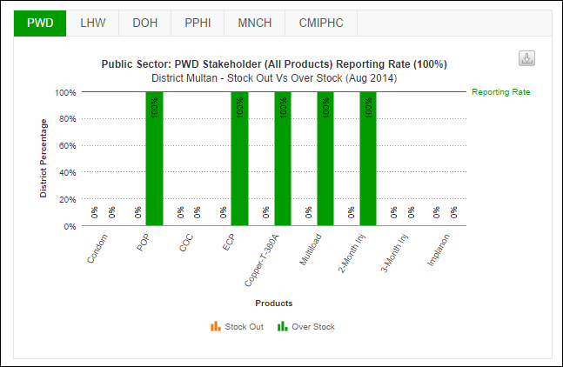

DESCRIBE the Stock Issue and Stock on Hand. TELL participants that this graph provides information about stock issue and quantities on hand of all products managed in the database. The stock issue vs stock on hand graph for each product in the selected district shows the availability of stock percentages for the selected stakeholder.

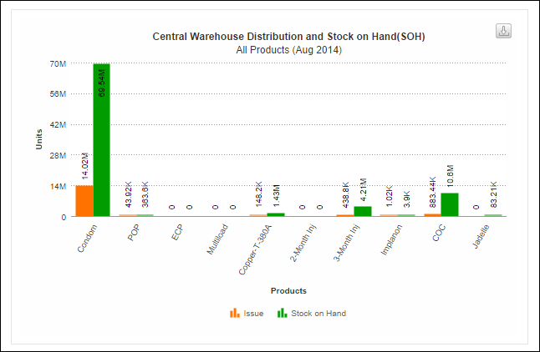

DESCRIBE the consumption and average monthly consumption graph. TELL participants that this graph summarizes the logistics indicators for stock consumption and its comparison with the average monthly consumption for the selected district. TELL participants that they can view graph for a specific stakeholder on the dashboard.

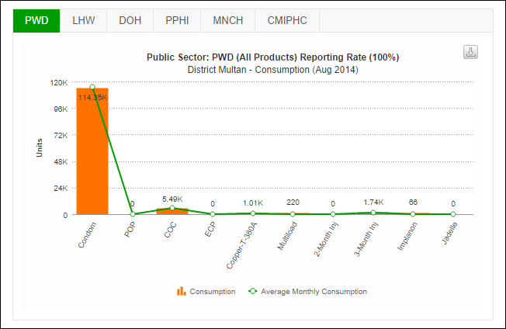

DESCRIBE the graph for couple year protection (CYP). TELL participants that couple year protection provided by all contraceptive products in the selected district can be view in a graphical manner from here.

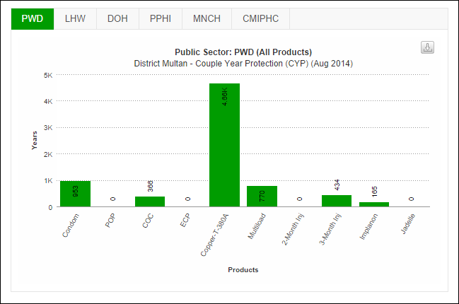

TELL participants that CYP values for each stakeholder as well as product can be viewed on the provincial map for all districts.

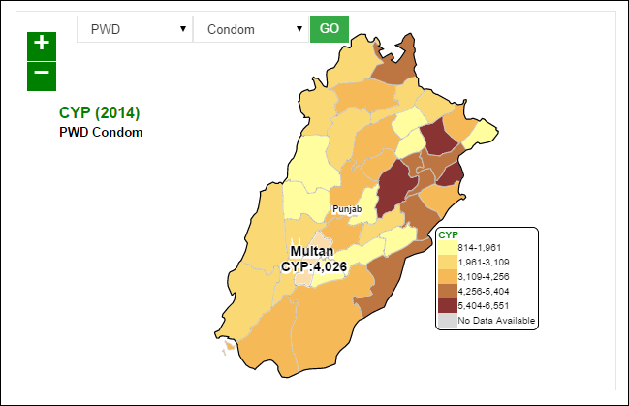

GIVE participants scenarios to view:

* Stock Distribution
* Stock on Hand
* Stock Consumption
* Product Summary
* Month of Stock
* Couple Year Protection

ASK participants to view the desired graphs using the above options. GO around the hall to see if all have developed the required graphs.

### Activity 8.2: Accessing & Analyzing Reports (Lecture + scenarios + discussion) – Time: 60 minutes

CONGRATULATE participants on successfully understanding the basics of dashboards in the last session. TELL participants that they will now be able to understand and interpret reports, maps and graphs easily. TELL participants that they need to clearly understand how to extract required reports from cLMIS.

ASK participants to share their understanding of how the data is collected from individual reports. They may respond that it is collected and computed in central server.

TELL participants that we are now going to talk in detail about reports. The reports summarize the cLMIS data in meaningful ways.

EXPLAIN the type of reports available in cLMIS. TELL participants that reports are summarized at level from national to district. In addition, field and district store data can also be extracted separately through District and Field reports respectively.

TELL participants that they can get to know the distribution of stock of particular product from national to field level through the ‘Stock availability report’. The stock availability report provides the available stock at each level of supply chain i.e. from central store to district.

SHOW what type of indicators the reports summarizes. ASK participants to recall their understanding of consumption, average monthly consumption and stock on hand from the previous session. EXPLAIN participants that LMIS computes reporting rate by dividing the number of districts which had reported in LMIS with the total number of districts, i.e.

***Reporting rate = Number of districts having reported / total number of districts***

TELL participants that reporting rate helps managers to monitor the timely reporting from districts.

The availability rate gives the ‘months of stock’ at each level in the pipeline and thus quickly identifies the stock distribution issues e.g. under stock and over stock situations.

Demonstrate how to ACCESS reports by opening the LMIS first <http://www.lmis.gov.pk/>

ASK all participants to browse to the report and GO around the hall to confirm all have been successful.

DESCRIBE the National Summary Report. TELL participants that National Summary Report provides aggregate for all logistics indicators (mentioned above). The national consumption reflects the total sum of issuance of a commodity from all district stores in Pakistan.

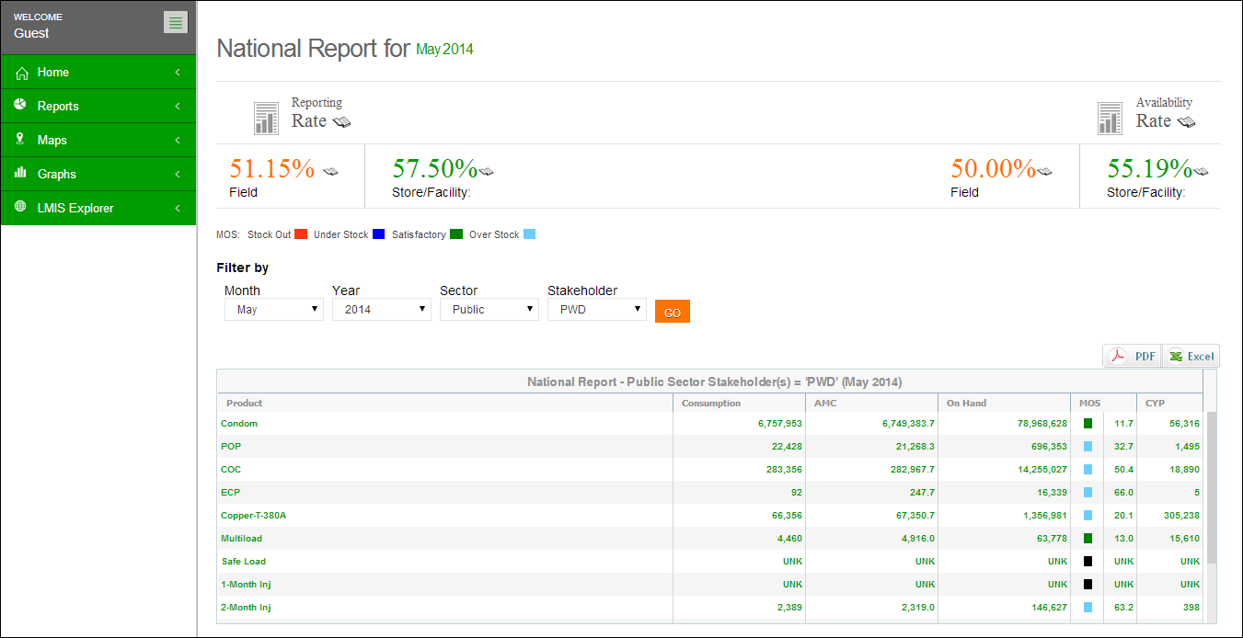

**Reporting and Availability Rates are displayed here**

**Table displays National Summary of each contraceptive**

**Use Filter options to filter data in the table below**

Give scenario-1 to participants and ASK them to develop the required Report. GO around the hall to ensure that everyone has developed the Report.

DESCRIBE the Stakeholder Summary Report. TELL participants that this report provides information about periodic consumption, average monthly consumption, quantities on hand of all products managed in the database and month of stock for each product. Average Monthly Consumption is calculated as average of aggregated consumption of the last three non-zero consumption months. Closing Balance is actual balance available at all reported facilities, which include central, provincial and district stores of all stakeholders.

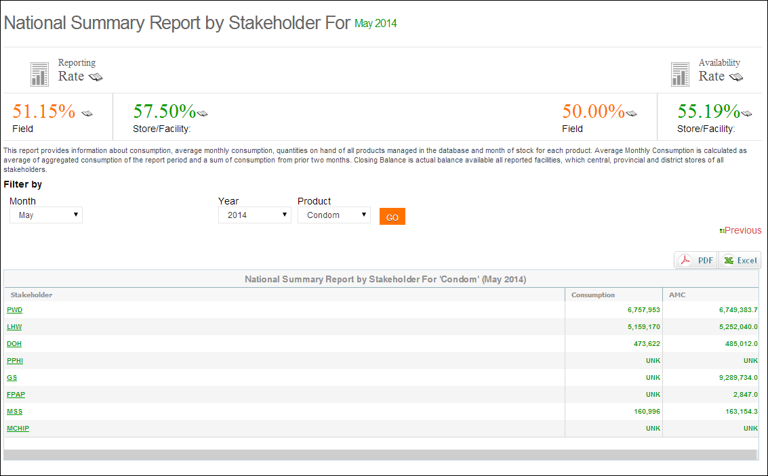

**Click GO.**

**Select Product**

Give scenario-2 to participants and ASK them to develop the required Report. GO around the hall to ensure that everyone has developed the Report.

DESCRIBE the Provincial / Regional Summary Report. TELL participants that provincial summary report summarizes the logistics indicators at the provincial level, in the same way National Summary Report does it at National level. TELL participants that there are options available to select all stakeholders or a specific stakeholder for the provincial report. TELL participants that they can obtain reporting rate and availability rate for provinces same as in the case of national report.

Demonstrate how to BROWSE the provincial summary report as shown below:

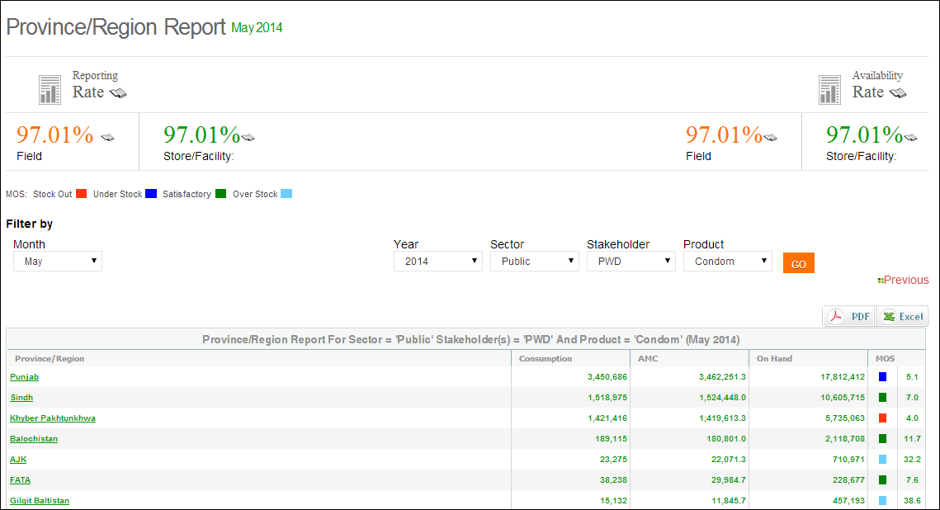

**Select Product & Stakeholder**

**Click GO.**

**Report for each province is displayed in the report table**

DISCUSS utility of provincial summary report, especially in the context of current devolution.

GIVE scenario-3 to participants and ASK them to develop the required report. GO around the hall to see if all participants had correctly developed the report.

DESCRIBE the district summary report. TELL participants that district summary report is most critical of the reports for district level policy makers and logisticians. TELL participants that all logistics indicators are reported stakeholder vise in district monthly report.

The district reports can also be viewed by reviewing the provincial level reports and then selecting a particular province of interest, the user will be able to view the district report for that province.

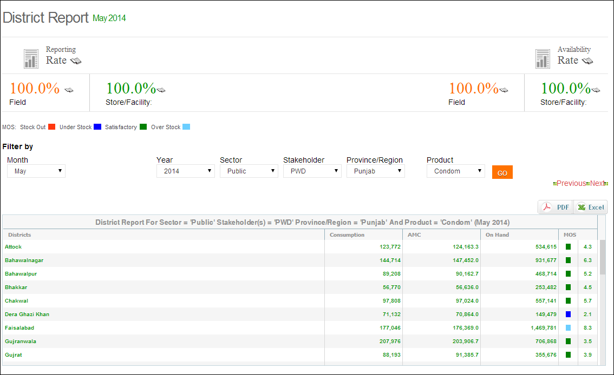

**Report for each district is displayed in the report table**

**Select Stakeholder, Province & Product**

**Click GO.**

Tell participants that the district report provides district level information on average monthly consumption, stock on hand, months of stock and couple years of protection by each commodity in each district.

BROWSE the district monthly report as shown and give each participant scenario-4 to develop the desired report. GO around the hall to see if each participant is able to browse the report correctly.

TELL participants that item availability report shows stock at every level of supply chain up to the district store level. TELL participants that item availability report gives availability by stakeholder and province.

TELL participants that reporting rate helps to analyze the number of districts which have successfully uploaded the data for a particular month. The reporting rate quickly identified the non-reporting districts and helps managers to resolve issues and challenges in reporting.

GIVE participants more scenarios for;

* District Stock Report
* Stock Availability Report
* Non/Reported Districts
* Quarterly Reporting Rate
* Provincial Reporting Rate
* Projected Contraceptive Requirements
* Central/Provincial Warehouse
* Provincial Yearly Report
* Private Sector Yearly Report
* Public-Private Sector Report

ASK participants to develop the desired reports using the above options. GO around the hall to see if all have developed the required reports.

### Activity 8.3: Accessing & Analyzing Maps (Lecture + scenarios + discussion) – Time: 60 minutes

TELL participants that they we will now talk about maps. TELL participants that Graphs are a visual way to present the data. In case of cLMIS, the same data visible in the form of reports can be displayed in the form of maps.

TELL participants to browse the available maps such as:

* Month of Stock
* Consumption
* Couple Year Protection
* CYP By Population
* Reporting rate

TELL participants that Month of Stock (MOS) map provides many filter options to the user. User can select Month, Year, Sector, Stakeholder, Province/Region, Product as well as Level to analyze MOS for each district in the selected province. The detailed information can be seen once the user clicks a particular district on the map.

**Click GO**

**Select the Sector, Stakeholder & Province**

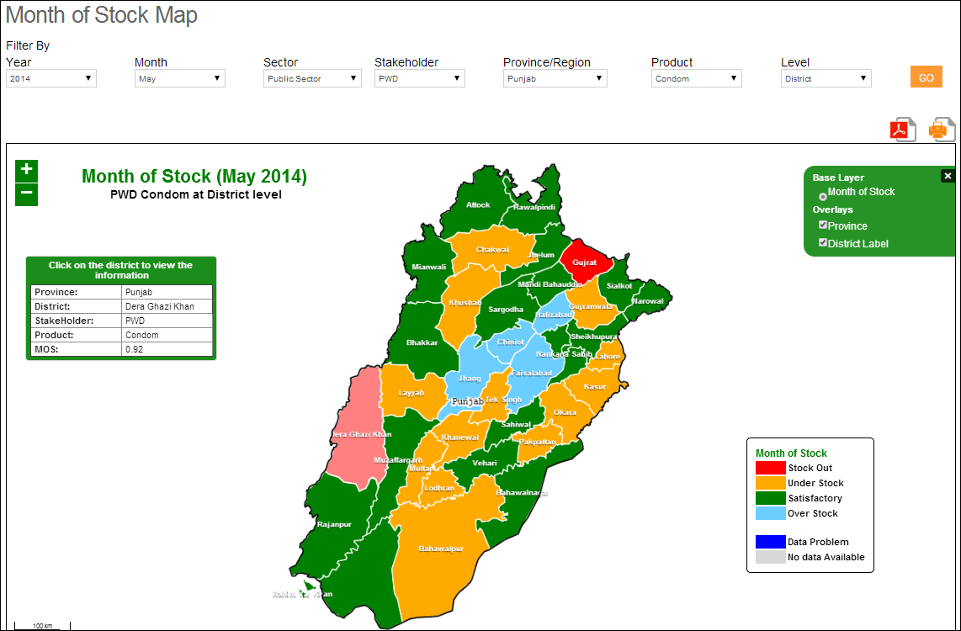

**Select Month &Year**

**Select the Product & Level**

**Click a District on map to see details**

Tell participants that Consumption map provides user with filter options such as Month, Year, Sector, Stakeholder, Province/Region, Product as well as Type (Consumption and Avg. Monthly Consumption) to analyze product consumption for each district in the selected province. The detailed information can be seen once the user clicks a particular district on the map.

**Select the Sector, Stakeholder & Province**

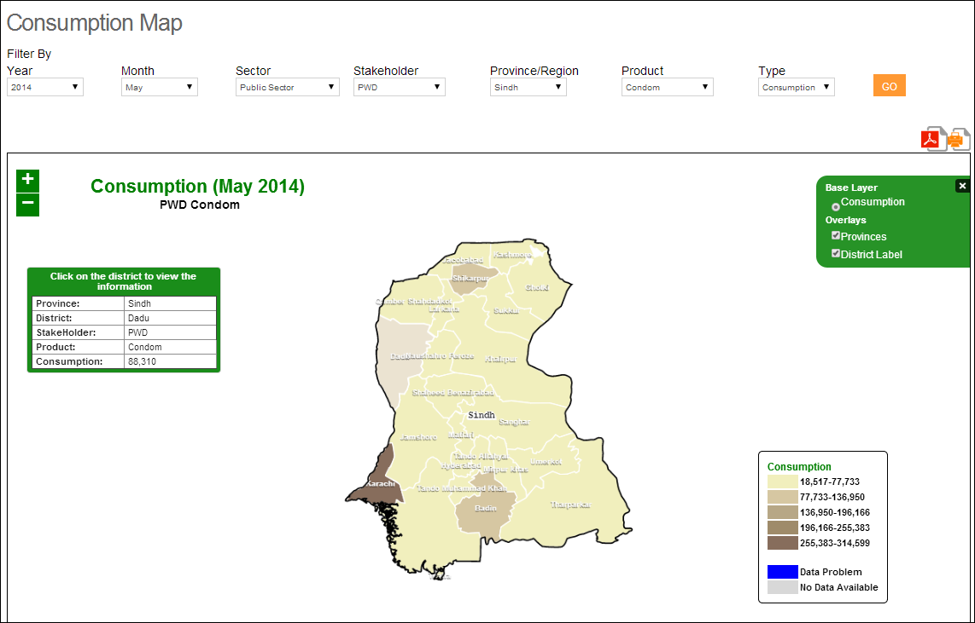

**Click a District on map to see details**

**Select Month &Year**

**Select the Product & Type**

**Click GO**

Tell participants that Couple Year Protection map provides user with filter options such as Month, Year, Sector, Stakeholder, Province/Region and Product to analyze number of couples protected for each district in the selected province. The detailed information can be seen once the user clicks a particular district on the map.

**Select the Sector & Stakeholder**

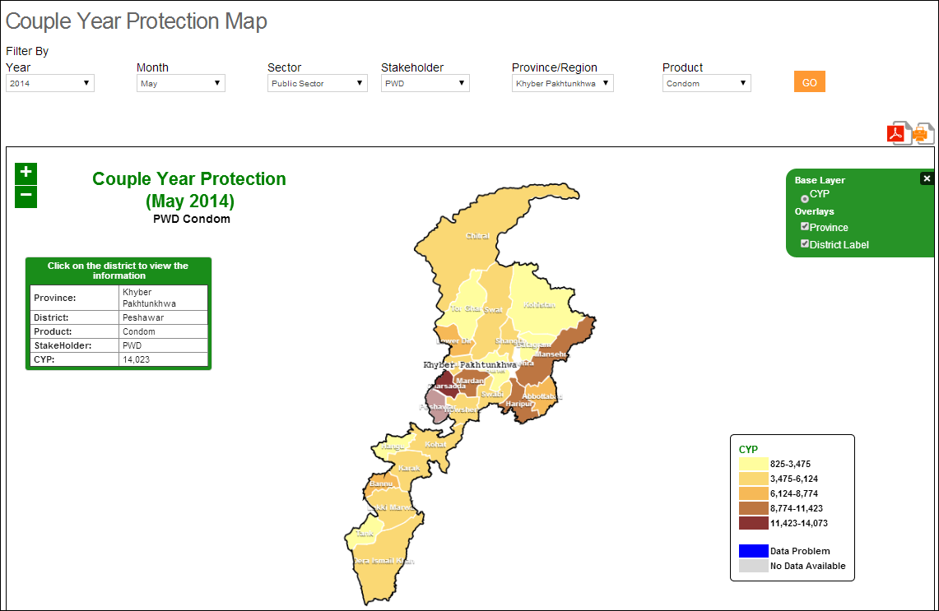

**Click a District on map to see details**

**Click GO**

**Select the Province and Product**

**Select Month &Year**

Tell participants that Couple Year Protection map can also be normalized based on the population of the province. It provides user with filter options such as Month, Year, Sector, Stakeholder, Province/Region and Product to analyze number of couples protected for each district in the selected province based on the population of that district. The detailed information can be seen once the user clicks a particular district on the map.

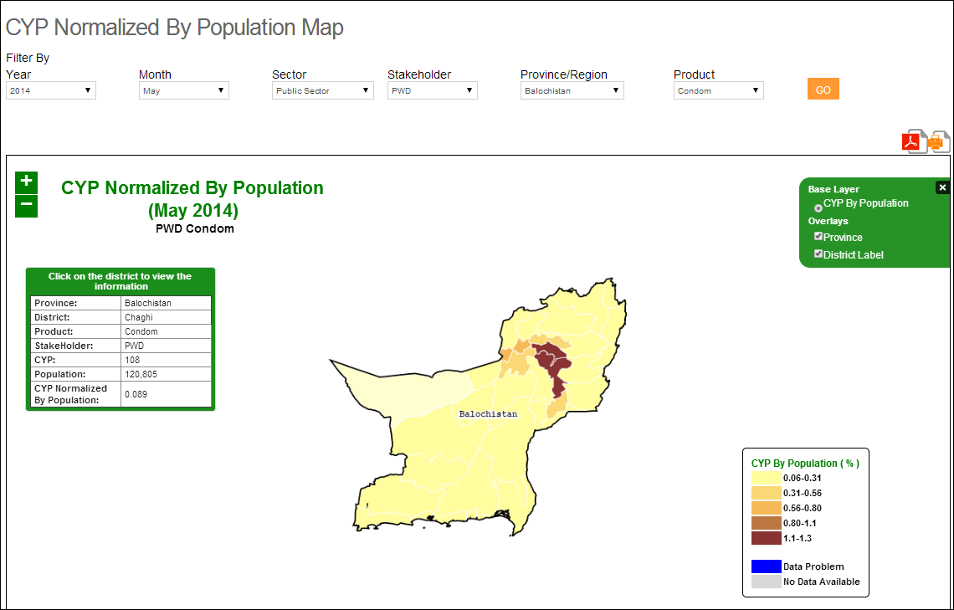

**Click GO**

**Select the Province and Product**

**Click a District on map to see details**

**Select Month &Year**

Tell participants that Reporting rate map shows the number of stores and facilities which have provided the report for each district. User can see filter options such as Month, Year, Sector, Stakeholder, Province/Region and Product to analyze the reporting rate for each district in the selected province based on the number of facilities in that district. The detailed information can be seen once the user clicks a particular district on the map.

**Select the Sector & Stakeholder**

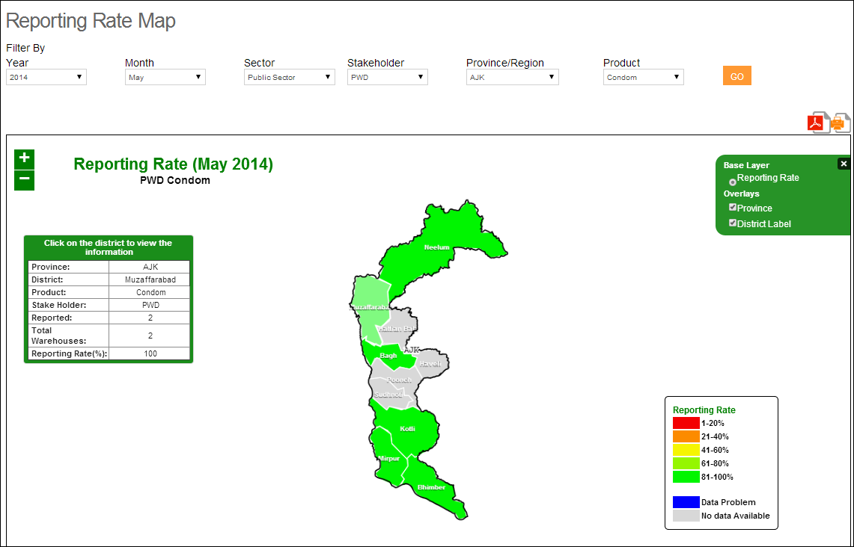

**Click a District on map to see details**

**Select Month &Year**

**Select the Province and Product**

**Click GO**

### Activity 8.4: Accessing & Analyzing Graphs (Lecture + scenarios + discussion) –Time: 60 minutes

TELL participants that they we will now talk about graphs. TELL participants that Graphs are a visual way to present the data. In case of cLMIS, the same data visible in the form of reports can be displayed in the form of graphs. TELL participants that graphs make it easy to observe trends and unusual changes over time. TELL participants that cLMIS graphs have time in months on x-axis and the indicators on y-axis. Elaborate the x and y-axis on chart if needed.

TELL participants that LMIS has two types of graphs, simple graphs and comparison graphs. ASK participants to browse the two types of graphs.

TELL participants that the graph indicators are the same as they have observed in reports. TELL participants that Couple Years of Protection (CYP) is an additional indicator in graphs. CYP is a measure representing the total number of years of contraceptive protection provided to a country's or community's family planning population.

For each contraceptive method, the CYP is calculated by taking the number of units distributed to clients during a specified period and dividing this number by a constant representing the number of contraceptive units needed or estimated to protect one couple from pregnancy for one year. The value of these constants is method-specific and is derived from empirical evidence on the amount of each method used by a couple during a year for full protection from pregnancy. Elaborate the CYP formula on the chart if needed for more clarity.

Show participants how to browse and select the indicators as given below:

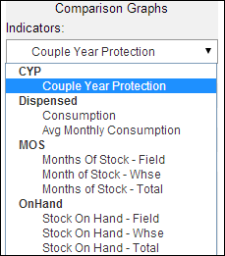

**Select Indicators**

TELL participants that there are various options to disaggregate the data in graphs. One of the options it to disaggregate the data on geographical basis. The data can be disaggregated on national, provincial and district level.

Demonstrate participants on how to select from various geographical options as shown below:

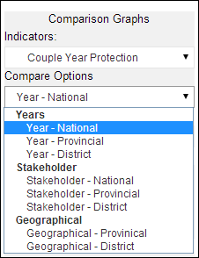

**Select Comparison options of Years, Stakeholder and Geographical location**

TELL participants that the LMIS data can be disaggregated by stakeholder. Demonstrate how to browse for and select stakeholder as shown below:

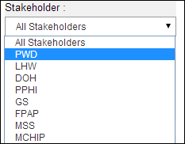

**Select the Stakeholder**

TELL participants that LMIS users can select the time interval they wish to observe the indicators trend for. ASK one of the participants to read the options of time interval.

TELL participants that LMIS users can select which years data should be displayed in graphs.

TELL participants that LMIS users can select the type of graph they want to create. The options available are bar and line graphs. For CYP, there is only one option of stacked bar in which proportionate contribution from each product is shown in a single bar in different colors. The stacked bar for different months can compare the total CYP and proportionate contribution from each product can show the share of that product for a particular month.

Demonstrate on how to select these options as shown below:

**Select multiple products for comparison**

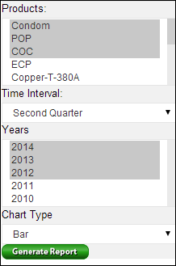

**After selecting all values, click here to generate report.**

**Select Line or Bar Chart**

**Select one\Multiple Year for comparison**

**Select time Intervals**

TELL participants that the graph shown is developed by following the instructions they have gone through. ASK participants to read the title of the graph.

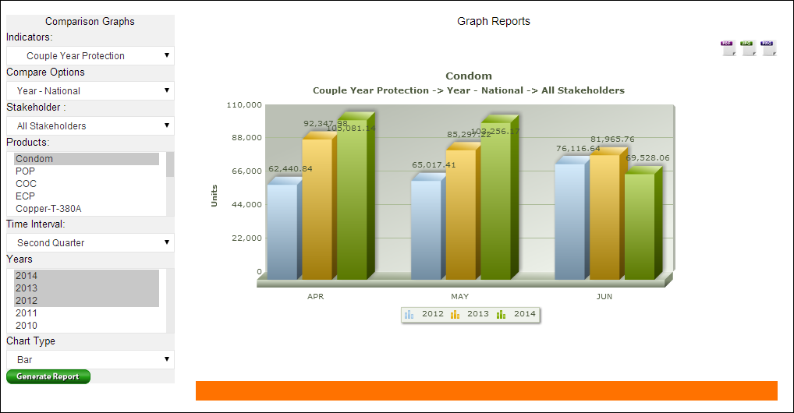

ASK participants about what options they need to select in the graphs menu to develop this graph. Facilitate participants to come up with correct options. Demonstrate how to develop the given graph and TELL participants that after they have selected all the required options, they need to click the button ‘Generate Graph’ to develop the graph.

TELL participants that this is another graph developed by following the instructions. ASK participants to develop this graph on their own computers. GO around the hall to confirm that every participants has completed this task. Help the participants still having difficulty in creating this graph

TELL participants that in addition to simple graphs, LMIS also gives the option of comparison among relevant indicators.

Demonstrate participants on how to browse the comparison graphs.

TELL participants that there are three types of comparison attributes available in cLMIS as given below:

1. Years – National, Provincial and District
2. Stakeholder – National; Provincial and District
3. Geographical – Provincial and District

TELL participants that it is essential to understand these comparison attributes to understand the comparison graphs. TELL participants that all options in comparison graphs menu are the same except with the addition of comparison attributes. A user can select the any of the option to compare the desired indicators. Following is the description of what every option compares;

1. Year
   1. Year – National: compares multiple years data at national level
   2. Year – provincial: compares multiple years data at provincial level
   3. Year – district: compares multiple years data at district level
2. Stakeholder
   1. Stakeholder – National: compares different stakeholders at national level
   2. Stakeholder – Provincial: compares different stakeholders at provincial level
   3. Stakeholder – district: compares different stakeholders at district level
3. Geographical
   1. Geographical – Provincial: compares provincial data
   2. Geographical – District: compares various districts

ASK participants to develop a graph based on the query posted. GO around the hall to see if participants have correctly developed the graph.

Show participants the resulting graph. This shows the actual data in a tabulated form. TELL participants to go through he tabulated data then observe how the data is shown in a visual form in the graph shown above. Participants should appreciate the ease of interpretation through graph.

ASK participants to develop the required graph. GO around the hall to make sure that every participants develops the graph on their computer.

# Session 9: Troubleshooting and accessing helpdesk

Time: 30 minutes

## Session objective

The participants should be able to

* Troubleshoot some basic issues encountered while accessing and using cLMIS
* Able to access helpdesk in case of any unresolved issues

## Documents to distribute

***Handout 9.1 – Troubleshooting and how to access helpdesk***

## Activities

### Activity 1: Troubleshooting

TELL participants there are some common issues being faced by cLMIS operator in successfully running the application. These issues can be easily resolved without any external help if cLMIS users follow some simple steps. TELL participants that they will now go through some basic issues and how to resolve them

**Issue one:** homepage does not appear. TELL participants that sometimes they may not be able to open the home page. The reasons for this issue are multiple and some of the common ones are;

1. Inserting wrong web-address
2. No connectivity to the internet

TELL participants to copy and paste the address <http://www.lmis.gov.pk/> in the web-browser. The users should write this address somewhere to enable them to check and verify if they are entering the correct address. TELL participants that they can also save the web-page in their browser’s favorite list for ease of access.

TELL participants that after checking and verifying the address; if the homepage still does not open, the participants should check the internet connection (open some other website). Internet connection should be restored before the homepage could open.

TELL participants to access the helpdesk by emailing at the system administrator <mailto:support@lmis.gov.pk> in case the above steps don’t work.

**Issue two:** Unable to login. TELL participants that this is also a very common problem and usually occurs due to inserting wrong user name or password. TELL participants that they should check if they have caps lock on in your computer before inserting the password. If the participant is still unable to login after verifying the user name and password, he/she should contact system administrator as mentioned above.

# Session 10: Group work

Time: 10.0 hours

## Session objectives

* To enable participants to have an in-depth understanding of LMIS application
* To enable participants to present key LMIS concepts through presentations

## Documents to Distribute

*Handout 10.1 Group work 1:* ***Data entry***

*Handout 10.2 Group work 2:* ***Inventory Management***

*Handout 10.3 Group work 3:* ***Requisitions & Gate Pass***

*Handout 8.2 Group work 4:* ***Dashboards***

*Handout 8.2 Group work 5:* ***Reports***

*Handout 8.3 Group work 6:* ***Maps***

*Handout 8.3 Group work 7:* ***Graphs***

## Activities

### Activity 1: Group work 1: Data entry – Time: 2 hours

Distribute handout 10.1. Divide participants in groups of three to four randomly. ASK each group to go through the handout. Answer any questions to clarify the group work. ASK participants to start working on the computers and complete all tasks listed in the group work. ASK participants to develop a presentation demonstrating the completed tasks.

During the group work facilitators should go around the hall to see how the groups are performing. Facilitate the groups to complete the tasks wherever they are having difficulty. After 1.5 hours, call time and assemble all groups for presentations. Allot ten minutes to each group for a presentation of 3 to 5 minutes and discussion of 5 minutes.

### Activity 2: Group work 2: Inventory Management – Time: 2 hours

Distribute handout 10.2. Divide participants in groups of three to four randomly. ASK each group to go through the handout. Answer any questions to clarify the group work. ASK participants to start working on the computers and complete all tasks listed in the group work. ASK participants to develop a presentation demonstrating the completed tasks.

During the group work facilitators should go around the hall to see how the groups are performing. Facilitate the groups to complete the tasks wherever they are having difficulty. After 1.5 hour, call time and assemble all groups for presentations. Allot ten minutes to each group for a presentation of 3 to 5 minutes and discussion of 5 minutes.

### Activity 3: Group work 3: Requisitions & Gate Pass – Time: 1 hour

Distribute handout 10.3. Divide participants in groups of three to four randomly. ASK each group to go through the handout. Answer any questions to clarify the group work. ASK participants to start working on the computers and complete all tasks listed in the group work. ASK participants to develop a presentation demonstrating the completed tasks.

During the group work facilitators should go around the hall to see how the groups are performing. Facilitate the groups to complete the tasks wherever they are having difficulty. After 45 minutes, call time and assemble all groups for presentations. Allot five minutes to each group for a presentation of 3 to 5 minutes.

### Activity 4: Group work 4: Dashboards – Time: 1 hour

Distribute handout 10.4. Divide participants in groups of three to four randomly. ASK each group to go through the handout. Answer any questions to clarify the group work. ASK participants to start working on the computers and complete all tasks listed in the group work. ASK participants to develop a presentation demonstrating the completed tasks

During the group work facilitators should go around the hall to see how the groups are performing. Facilitate the groups to complete the tasks wherever they are having difficulty. After 45 minutes, call time and assemble all groups for presentations. Allot five minutes to each group for a presentation of 3 to 5 minutes.

### Activity 4: Group work 5: Reports – Time: 1 hour

Distribute handout 10.4. Divide participants in groups of three to four randomly. ASK each group to go through the handout. Answer any questions to clarify the group work. ASK participants to start working on the computers and complete all tasks listed in the group work. ASK participants to develop a presentation demonstrating the completed tasks

During the group work facilitators should go around the hall to see how the groups are performing. Facilitate the groups to complete the tasks wherever they are having difficulty. After 45 minutes, call time and assemble all groups for presentations. Allot five minutes to each group for a presentation of 3 to 5 minutes.

### Activity 5: Group work 6: Maps – Time: 1 hour

Distribute handout 10.5. Divide participants in groups of three to four randomly. ASK each group to go through the handout. Answer any questions to clarify the group work. ASK participants to start working on the computers and complete all tasks listed in the group work. ASK participants to develop a presentation demonstrating the completed tasks

During the group work facilitators should go around the hall to see how the groups are performing. Facilitate the groups to complete the tasks wherever they are having difficulty. After 45 minutes, call time and assemble all groups for presentations. Allot five minutes to each group for a presentation of 3 to 5 minutes.

### Activity 6: Group work 7: Graphs – Time: 1 hour

Distribute handout 10.6. Divide participants in groups of three to four randomly. ASK each group to go through the handout. Answer any questions to clarify the group work. ASK participants to start working on the computers and complete all tasks listed in the group work. ASK participants to develop a presentation demonstrating the completed tasks

During the group work facilitators should go around the hall to see how the groups are performing. Facilitate the groups to complete the tasks wherever they are having difficulty. After 45 minutes, call time and assemble all groups for presentations. Allot five minutes to each group for a presentation of 3 to 5 minutes.

