FELTP at a Glance
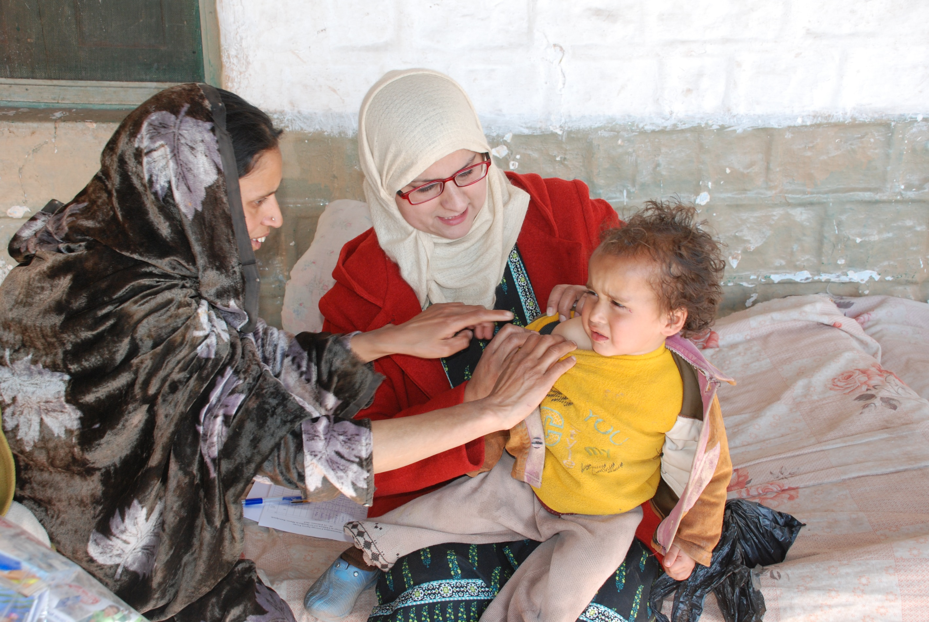

Program Dates
2007: Pakistan FELTP launched first training
2009: Acute Viral Hepatitis surveillance
2011: NSTOP
2013: Veterinarian joined 2 years FELTP program
2014: Pakistan Army doctors joined 2 years FELTP program

Institutionalizing FELTP
Director of FELTP: Executive Director of Pak NIH
Division of Field Epidemiology and Surveillance (DFES) Pak NIH
Provincial Disease Surveillance and Outbreak Response units (PDSRU)
A federal unit at NIH
Provincial Health Development Centers (PHDC) as new provincial hubs of trainings.

Embrace

8 Cohorts (134 Field Epidemiologists):

- 88 graduates from the two year training program (6 cohorts)
- 46 fellows currently enrolled in two cohorts (7th – 8th Cohort)
- Over 1000+ government officials trained through short courses

NSTOP (National Stop Transmission of Polio):
2011: 16 FELTP trainees were deployed to 16 high-risk districts for polio as N-STOP officers in a new program designed by FELTP with partner’s collaborations
2015: 63 NSTOP officers (deployed to 48 high-risk districts/areas and 8 to provincial EOCs/ ERU). NSTOP remains one of the only government owned program within the Global Polio Eradication Initiative

Sentinel Surveillance for Viral Hepatitis (A, B, C, D, E):

In response to the request of Prime Minster’s Hepatitis Control Program, the FELTP established 5 sentinel surveillance sites-one in each province and one in Islamabad to identify risk factors for all types of viral hepatitis with a laboratory component. Monthly reports are being shared regularly with all hepatitis control programs in Pakistan.

IHR 2005 compliance:
Under the leadership of Ministry of Health, FELTP facilitated drafting legislation for disease reporting which also fulfilled requirements for IHR 2005 compliance. A legislative document was approved with provincial feedback by MOH.

One Health:
To strengthen zoonotic disease surveillance system and enhance collaboration with human and animal health sector a cooperative agreement was done with the National Agriculture Research Center (NARC). Six veterinarians are currently enrolled in the FELTP.

